

Home AUP

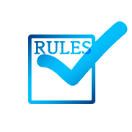Example of Basic Rules of Our Home:

* I will complete all my homework before turning on the television or computer.
* I will complete all my chores before turning on the TV or computer.
* I will not get on games or websites that I have been told not to get on.
* I will shut computer/TV down when I am told to, the first time every time.

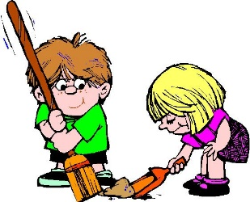Daily Chore List:

* Get dirty laundry from my room.
* Pick up all my toys from the floor.
* Take the trash to the road.
* Clear the table after supper each night.

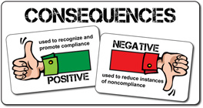Consequences for Breaking our Home Rules:

* 1st offense: take away one day of TV/Computer.
* 2nd offense: take away one week of TV/computer time.
* 3rd offense: Grounded for one month from all electronics

I, ____________________, promise to follow all of the rules that have been told to me in my home. I know that breaking these rules will result in consequences that I have also been told.

Parent Signature: _______________________________________________

Childs Signature: _______________________________________________

Date__________________ Date: __________________________________