This week in Ms. Miller’s classroom:

* **Annual Spooky Cake Walk**

Tuesday, October 15 at 6:30 P.M.

Bring your spookiest costumes and cakes! There will be a contest of who has the Spookiest cake. The winner will receive a whole pumpkin of candy!!

* **Pep-Rally**

Wednesday. October 18 at 2:00 P.M.

The students will go to the elementary gym to cheer and chant on the sr. high football team as they play minute-to-win-it games! Parents are welcome to come. Pick-up is at the gym- **Not cafeteria**

* **Weekly Spelling Test**

This week the students will be tested on ten sight words. There is a list in their take home folder

* **Show N’ Tell**

After the spelling test, we will have show n’ tell. The students are encouraged to bring their favorite costume or a picture of their favorite costume. The **spookiest costume** will get a prize!!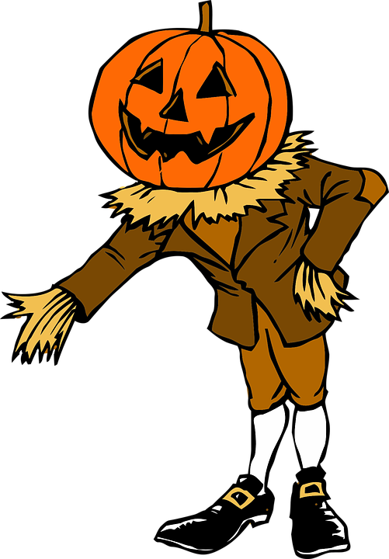

Upcoming Events in the Community:

* **Annual Ghostly Can Drive**

Batesville Aquatic Community Center; Saturday 27 at 11:00

Lunch will be provided and games

Those attending are encouraged to bring the following items:

* Peanut Butter
  + JIF
  + Skippy Natural
* Canned Items
  + Beans
  + Corns
    - Sweet Corn
    - Whole Kernel
* Boxed Cereal
* Mac N’ Cheese

Suggested Activities at home:

* **Carve a pumpkin**
* **Practice spelling words** (here is a list): From, know, any, live, my, stome, think, over, put, when
* **Read the weekly take home book**

In the take home folder, there is a Ready-to-read book called *Scaredy-Pants!* 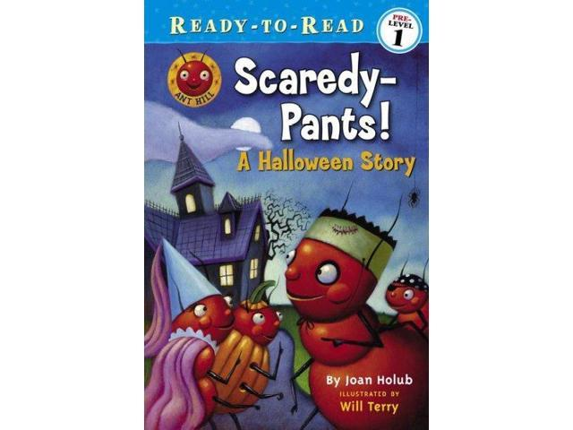

This week for the District:

* **Volleyball Sr. high district** tournament at westside (When: Monday, Oct. 15 @ TBa)
* **Parent teacher Conferences**

3:30 P.M.- 7:00 P.M

* **JH football away @ Heber Springs**

7:00 P.M.

A Look into Next Week:

* **Weekly Spelling Test**

10 sight words

List will be put in take home folder this friday

* **Art Class**

For one week, we will have a guest art teacher to show the students abstract art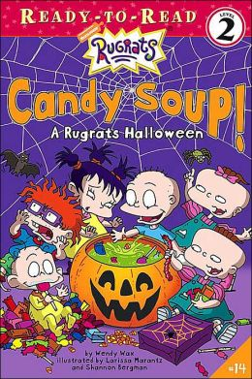

* **Next Ready-to-read Book:**

*Rugrats Candy Soup!*