Name Annie Shaw_____
Lesson Plan Template
Lesson Segment Focus Let Me Tell You A Story Real Quick______ Lesson _____1_______of____2______

Course & topic addressed ___Creating a Narration________ Date_3-25-2019______ Grade_8th___

Student Outcomes

Specific learning objectives for this lesson. | - Given an advance organizer students will prewrite a narrative using story elements.  - Students will applying knowledge of the elements of a plot to create a framework.  - Students will produce coherent writing that is appropriate for their grade level.
Describe the connection to previous lessons. (Prior knowledge of students this builds upon)
Knowledge of students background (personal, cultural, or community assets)

State Academic Content Standards

List the state academic content standards with which this lesson is aligned. Include state abbreviation and number & text of the standard. | W.8.3: Write narratives to develop real or imagined experiences or events using effective technique, relevant descriptive details, and well-structured event sequences.  W.8.4: Produce clear and coherent writing in which the development, organization, and style are appropriate to task, purpose, and audience.

Academic Language Support
What planned instructional supports might you use to assist students to understand key academic language to express and develop their content learning?  What will you do to provide varying supports for students at different levels of academic language development? | Word wall for ELL students:  Narrative - Narrativa  Climax - Clímax  Sequence - Secuencia  Exposition - Exposición  Resolution - Resolución  Protagonist - Protagonista  Antagonist - Antagonista  For students who need an easier story format, I will give them the following advance organizer:  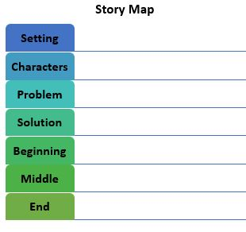

Key Vocabulary
What vocabulary terms/content specific terminology must be addressed for students to master the lesson? | Narrative; Sequences; Climax; Exposition; Resolution; Protagonist; Antagonist

Materials

Materials needed by teacher for this lesson. | Advance Organizer
Materials needed by students for this lesson. | Advance Organizer

Lesson Timeline with Instructional Strategies & Learning Tasks (This should be VERY DETAILED)

Amount of Time | Teaching & Learning Activities | Describe what YOU (teacher) will be doing and/or what STUDENTS will be doing during this part of the lesson.
5 minutes | Introduction:  Class Warm-Up Exercise | I will begin by asking the students to stand up. I will ask them to reach their hands down to their toes, then up to the sky, and then down to their toes again.  Then, I will ask the students to reach their hands to their left, as far down on their left as they can, then to go up way over their heads, and finally land on their right shoulder. Once they have done this twice, I will have them sit back down, and ask them,  “Do you know how to write a story?”
30 minutes | Instruction:  Advance organizer (How to write a story) | I will begin by handing out the advance organizers of ‘How To Write A Story’ to the students. They will all receive hand-outs that looks like the following:  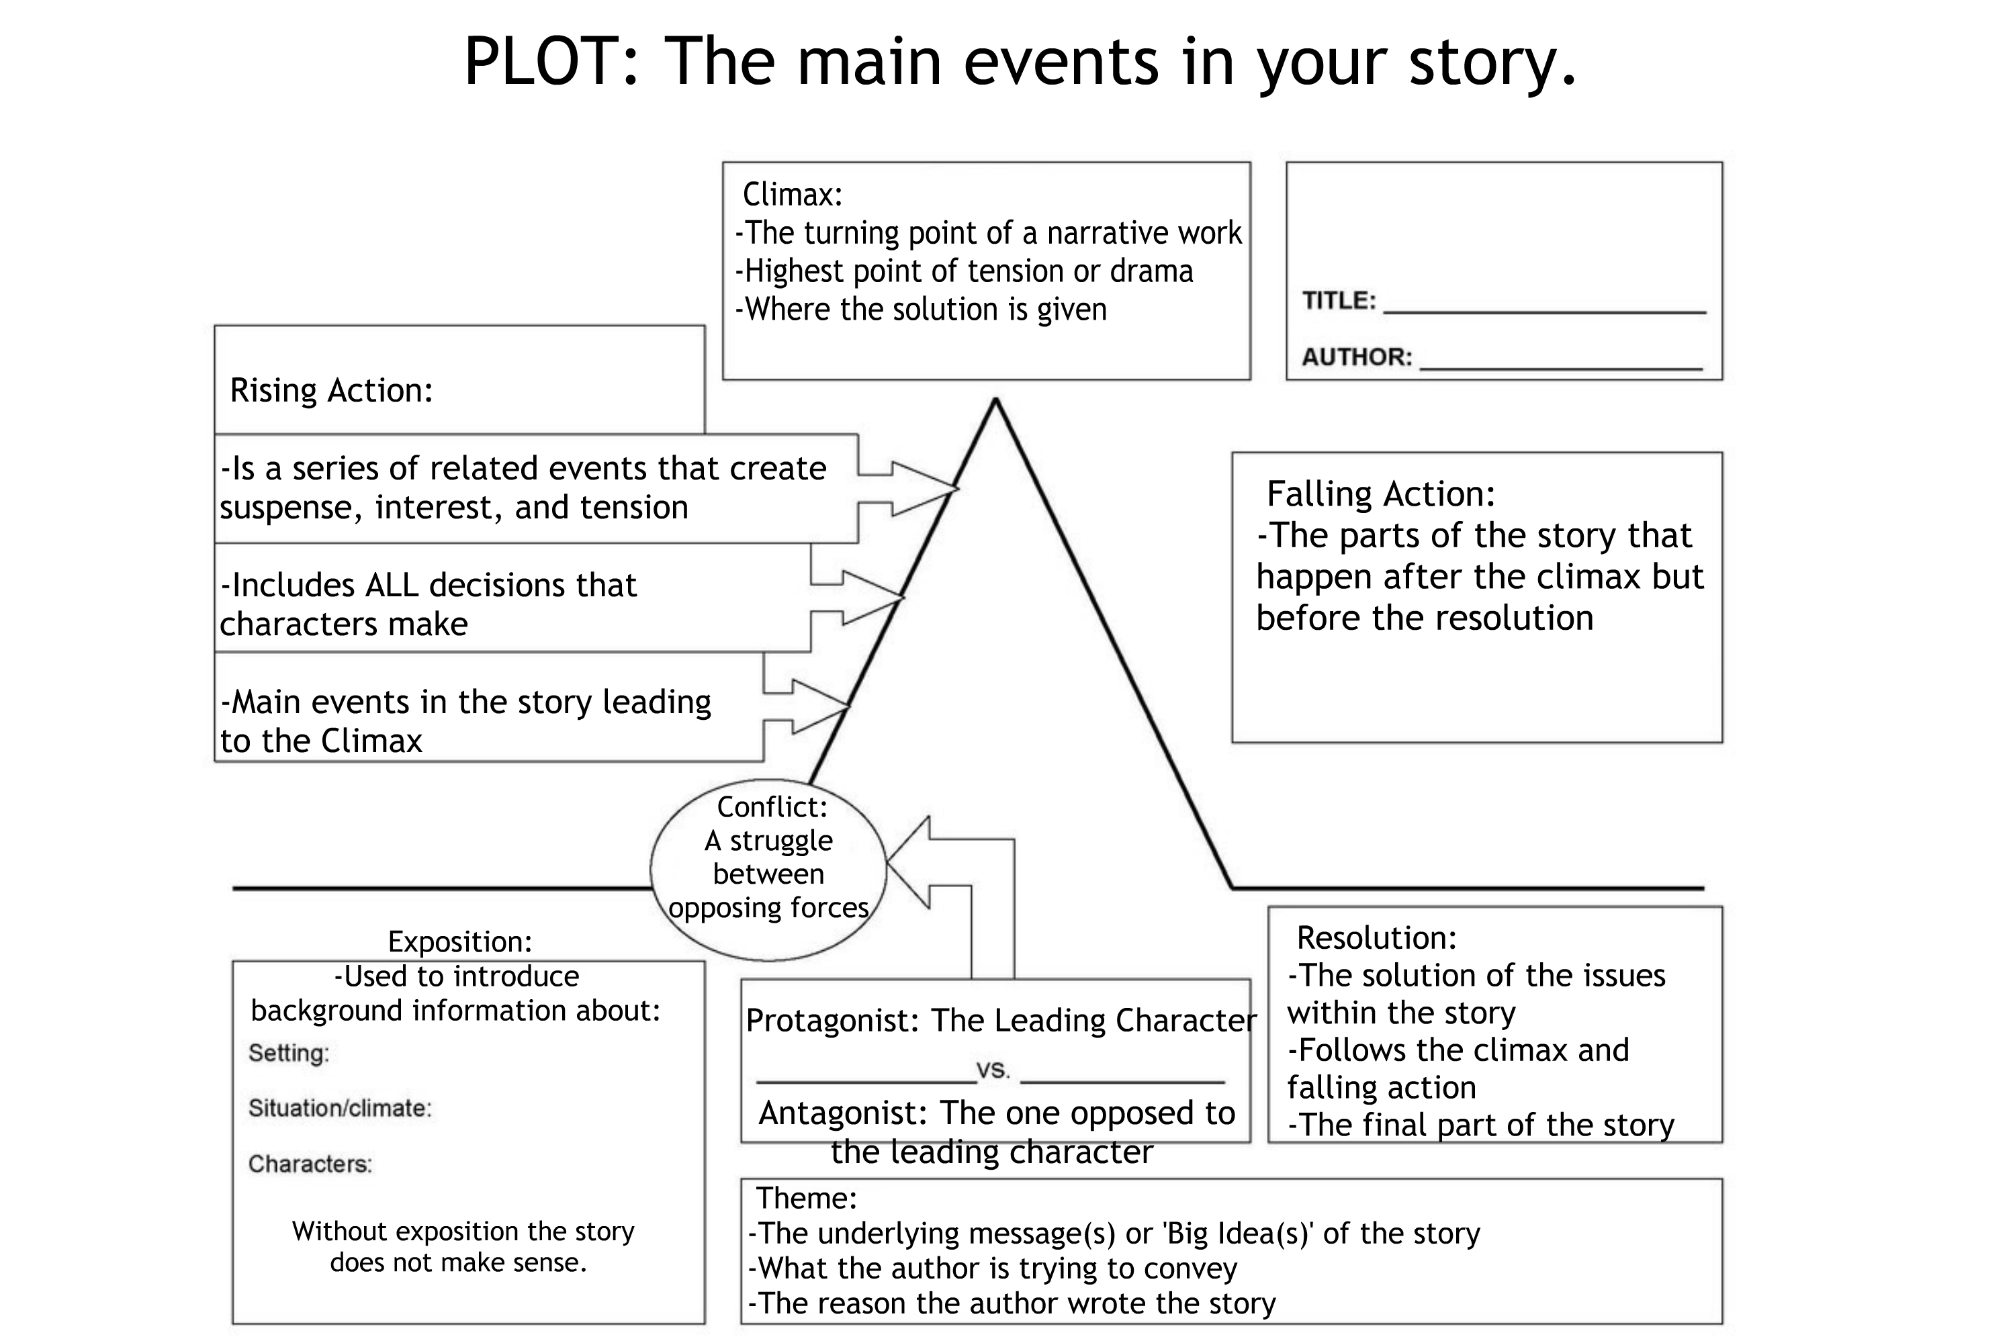  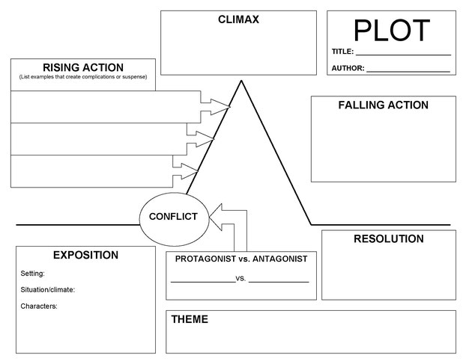  I will place them into groups based on their table arrangements. I will have the students sit partnered at tables and they will work with one another to create a story. They will use the advance organizer to create this as they practice making a short story. While they work together, I will walk through the class and watch the students, offering help if they haven’t started after five minutes or asking them questions such as, “Why would Protagonist do this? What does this mean? What story are you telling?”  There will be an extra five minutes of work time for those who need it. Those who finish early can discuss their stories with a friend (granted that their friend also finished early) quietly.  The students will be asked to self-assess themselves for their partners. Their self-assessment questions will be attached at the end of this document.
10 minutes | Closure:  Exit Slip | “Do you think you are ready to write your own story now? Our next assignment will be the creation of our own narrative.”  Then, before they leave, I will have the students use a google form as an exit slip. It will be over what they think their story will be about (and if they want to write the story they worked on today). This will be their exit slip and will be turned in before they leave.

Accommodations/Modifications
How might I modify instruction for:  Remediation?  Intervention?  IEP/504?  LEP/ESL? | There will be a more accessible advance organizer (an easier one) for students who require it.

Differentiation:
How might you provide a variety of instructional methods/tasks/instructional strategies to ensure all student needs are met? | For students who are ELL I will use a cognate list of the main vocabulary so that way it will help them better understand the lesson.

Assessments: Formative and/or Summative
Describe the tools/procedures that will be used in this lesson to monitor students’ learning of the lesson objective/s (include type of assessment & what is assessed). | ☐ Formative /☐ Summative | Advance Organizer
 | ☐ Formative /☐ Summative | Self-Assessment
 | ☐ Formative /☐ Summative | Exit Slip

Research/Theory
Identify theories or research that supports the approach you used. | Expository instruction  Direct Instruction  David Ausubel

Lesson Reflection/Evaluation
What went well?  What changes should be made?  How will I use assessment data for next steps? | TO BE FILLED IN AFTER TEACHING

Include supporting material such as slides, pictures, copy of textbook, and handouts for any activities students will be using as part of your lesson.

*adapted from: http://webcache.googleusercontent.com/search?q=cache:EsQcNWuG1ZoJ:web.mnstate.edu/harms/StudentTeachers/edTPA-LessonPlan.doc+&cd=2&hl=en&ct=clnk&gl=us; http://www.moreheadstate.edu/getmedia/cd3fd026-939f-4a47-a938-29c06d74ca01/Lesson-Plan-and-Reflections.aspx; http://www.mcneese.edu/f/c/9cb690d2/Lesson%20Plan%20Rubric%20Aligned%20with%20InTASC.docx;https://www.uwsp.edu/education/Documents/edTPA/Resource12.pdf; https://www.uwsp.edu/education/Documents/edTPA/Resource11.pdf; https://www.uwsp.edu/education/Documents/edTPA/Resource11a.pdf; https://www.uwsp.edu/education/Documents/edTPA/LessonPlanTemplateSOE.docx; https://www.uwsp.edu/education/Documents/edTPA/SpecEdLessonPlanGuide.docx; https://www.uwsp.edu/education/Documents/edTPA/SpecEdLessonPlanTemplate.docx

Self-Assessment

Partner’s Name: _________________________________________

Name: ______________________________________________

Rate yourself on the following (1 = low; 5 = high):
I embraced turn-taking and listening and did not interrupt my partner:
1 2 3 4 5

I listened carefully to my partner as they presented ideas.
1 2 3 4 5

I fully participated in the creation our story elements.
1 2 3 4 5

I followed the steps of the advance organizer to create the frame for our story.
1 2 3 4 5

