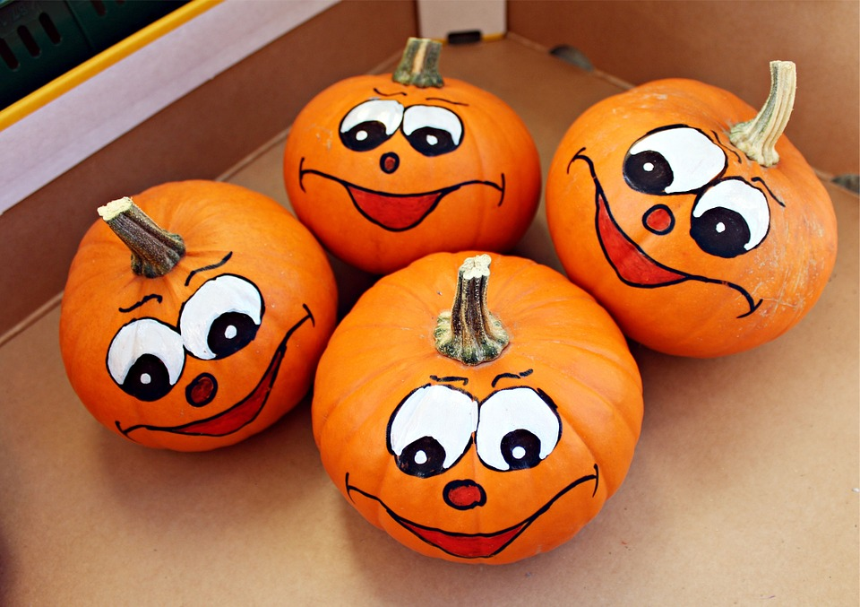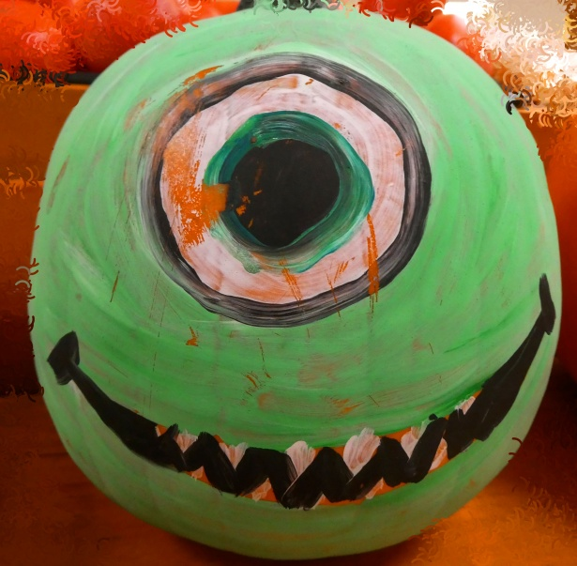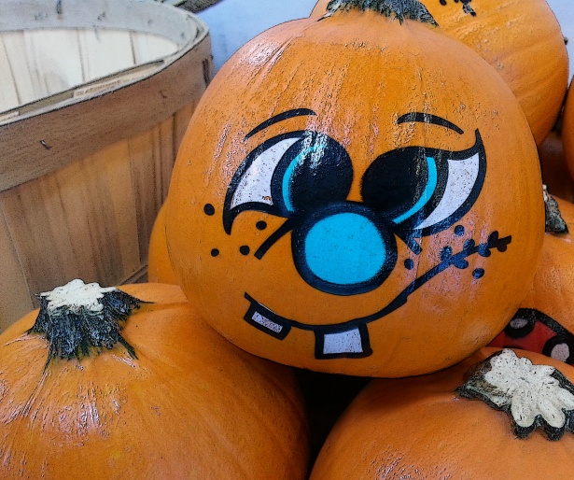

**Pumpkin Painting Workshop**

**Artist Rebekah Williams will guide you through this fun workshop - from paper to pumpkin! Hosted by pages of the past.**

**Saturday, November 17th at 10a.m. Workshop is $10. Bring your own real or artifical pumpkin!**

**If you would rather have the artist paint your pumpkin, simply drop it off at Pages of the Past before November 10th. Cost is $15.00**

**Call 818-443-0578 to reserve your spot!! Hurry! Seating is limited!!**