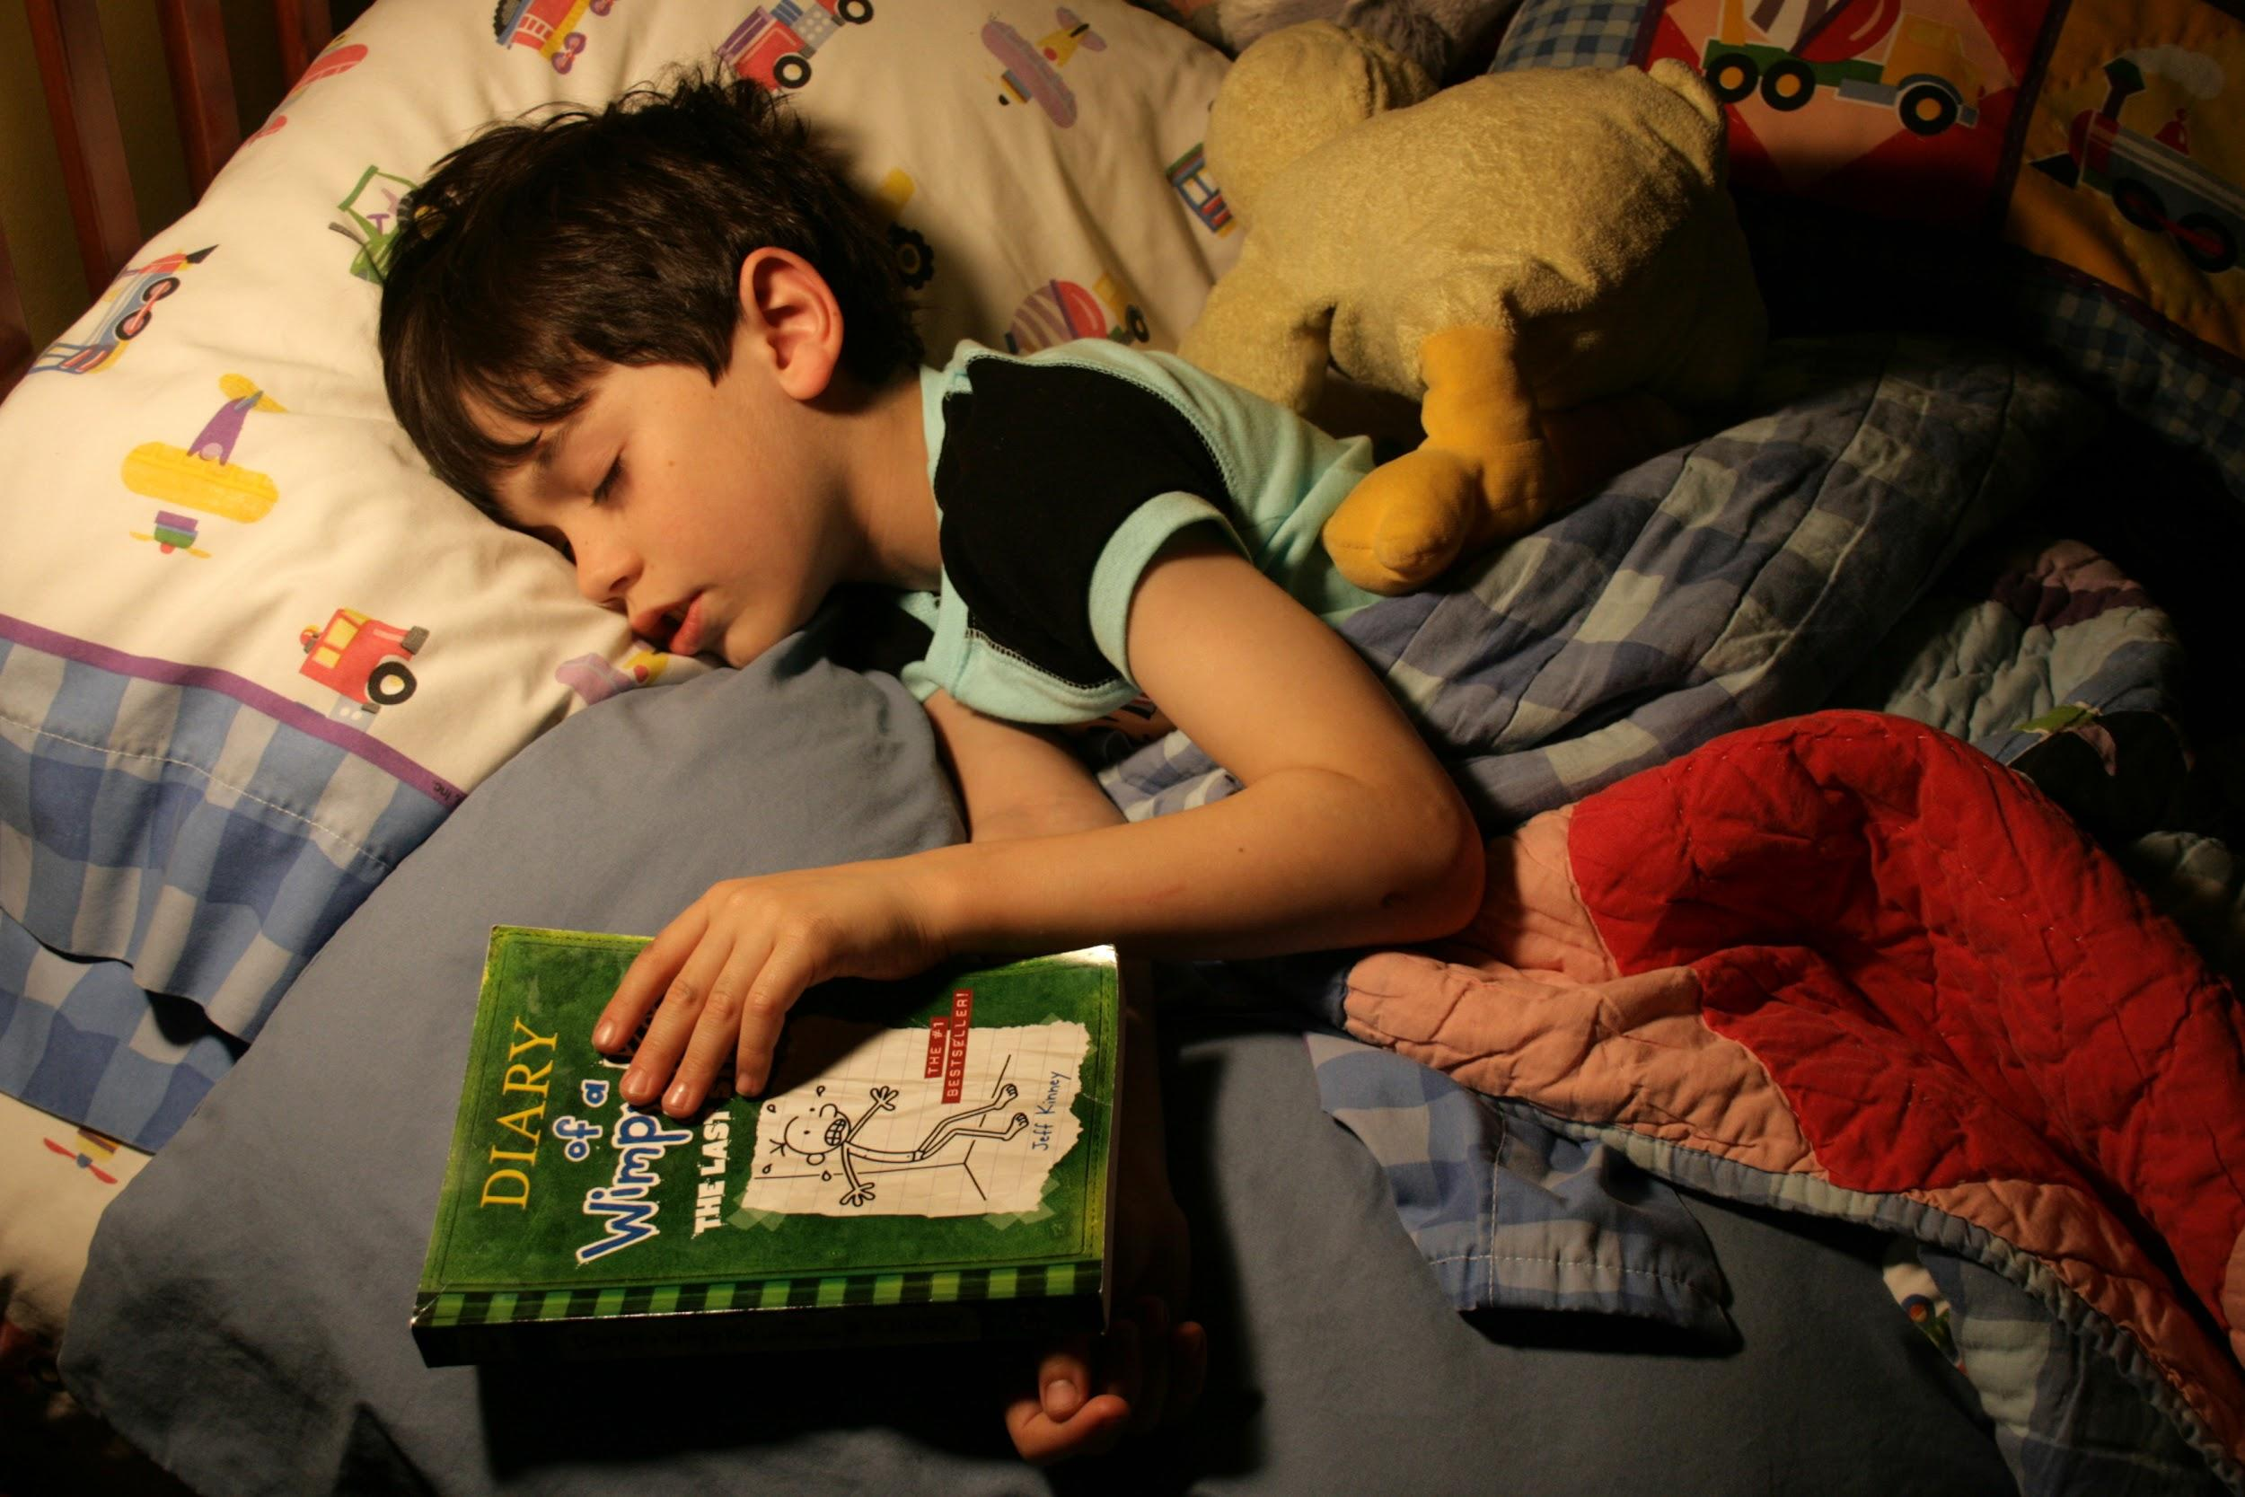

**For any questions and to join please contact Ms.Stephan at stephan.petty@smail.astate.edu**

**“The world belongs to those who read.”**

**-Rick Holland**

**Book club is a great opportunity to strengthen your vocabulary and reading skills. I would encourage each and everyone of my students to consider joining. Remember you do have 6 book reports due this year alone. So I should have no excuses for not joining. This is a great way for you to knock out your assignments and have fun with friends.**