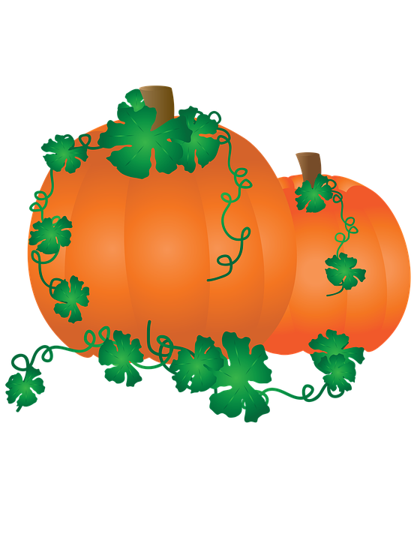

**For more information call 870-974-3322 or visit www.kkcaschool.org**

**Friday & Saturday**

Ste

**ACTIVITIES**

**Petting Zoo**

**Corn Maze**

**Pony Rides**

**Airsoft Wars**

**Bounce House**

**Carnival Games**

**Hay Rides**

**And More!**

**4:00 TO 9:00 P.M.**