On-Line Tools
By Susan Abshier
#1 Flip Grid
URL | https://info.flipgrid.com/
Description | Accessible by wed browser and application, Flip Grid is an interactive video tool. Teachers can create classrooms and within classrooms, can create topics. Students respond to prompts with videos less than 2 minutes long. Students can connect links to their video and a short description. There are many ways to customize the classroom. For example, the teacher can allow the option for the students to comment and likes each other videos. With comments, the teacher may enable a setting where he or she must preview the comment before it is show, or have it post immediately.
Category | Video and Collaboration
How I will use it | For my example, I would have taken students to the library to pick out a book to read. The students have to choose a book they want to read and talk about it in the Flipgrid video.  There are endless possibilities to using Flipgrid in any content area. For math, an educator could have students work out a problem and explain it. For science, an educator could have students explain the cell cycle. For History, students can each give a short biography of one of the US Presidents. For English, students could record a poem they wrote! So many options!
Play Example | https://flipgrid.com/c090eb9c

#2 Note App
URL | https://noteapp.com/
Description | This is a bulletin board similar to Padlet. It allows students to make post its, share links and files, and it even has a chat window! The teacher can customize the background and there are multiple post-it colors. The size of the font cannot be changed but you can zoom in and out with the slide bar on the top left. One really cool thing I like about this tool is that there is a map where you can easily navigate the many notes if the board gets really big.
Category | Collaboration and Note Taking
How I will use it | - Students taking personal notes  - Students taking notes during Jigsaw lessons  - Students journal throughout the year (one post-it a day)  - Preparing for presentations  - Group research  - Group Planning
Play Example | https://noteapp.com/Jj0qGtR6Wv

#3 Jeopardy Labs
URL | https://jeopardylabs.com/
Description | This is an online customizable Jeopardy game! You create the subjects, questions, answers, point amounts, and who can access it. With the paid version you can add picture and links. There are options for typing in raised and root numbers (like x^2). I really like this tool!
Category | Game, Review, Quiz
How I will use it | - Content review before a test  - Option for student project creation  - Introduction to new topic  - Team building activity ( get to know each other)
Play Example | https://jeopardylabs.com/play/play-671

#4 Vecteezy
URL | https://www.vecteezy.com/
Description | Vecteezy is a image search engine with access free fair use pictures and options to buy rights to using other pictures and videos.
Category | Multimedia Search Engine
How I will use it | Students/ I can use this as opposed to Google Image Search to find pictures/videos for projects, one pagers, posters, presentations, research, notes, and other image needs. This is a great tool because it requires students to recognize the right others have to their intellectual property. It exposes students to copyright laws.
Play Example | https://www.vecteezy.com/photo/1224119-french-bulldog-with-a-ball There was not much play I could do but here is a free downloadable picture of a cute dog I found! Also here is a sunflower that you can buy access to: https://www.vecteezy.com/photo/2230432-close-up-of-a-sunflower  A free downloadable video of sunflower field! (So fun!) https://www.vecteezy.com/video/2021482-tracking-drone-shot-of-sunflower-plantation-in-thailand

#5
URL | https://paintz.app/
Description | This is an online painting tool! It has options to draw with pencil, paint, fill in bucket, squares, circles, lines, arches, and spray paint. There are also text box options with bold, underline, different fonts, sizes, and colors. There is a copy and paste selection, a drag and drop, and eye drop color picker. You can also upload pictures and do everything on top of them!
Category | Painting
How I will use it | - One pagers (students use one page to give info about a thing they research)  - Creating venn diagrams  - Not taking  - poster  - projects  - inspirational quote pictures  - infographic (simple)  - advertisement (simple)
Play Example | 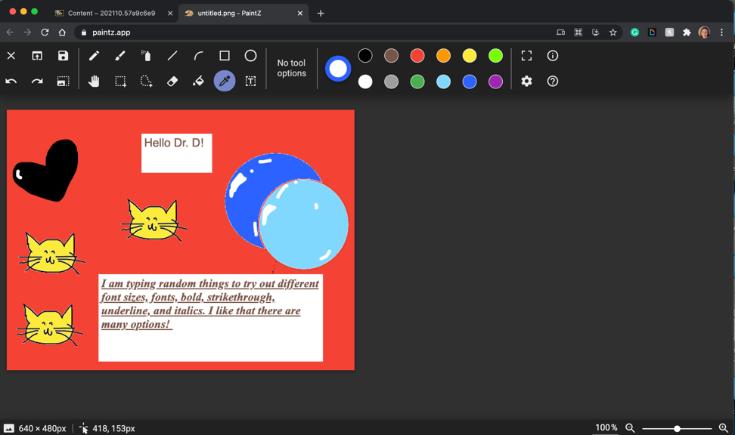  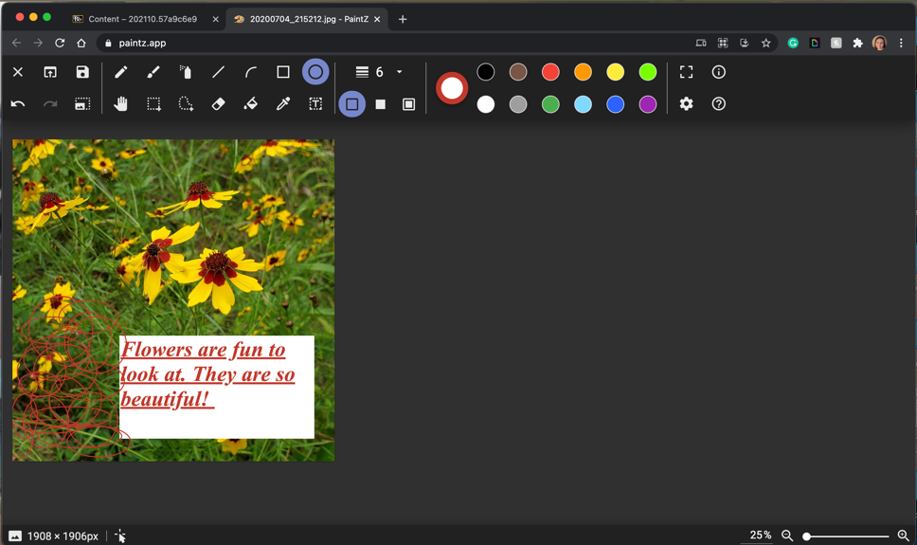

#6 Clip Champ
URL | https://app.clipchamp.com/
Description | This is a video tool where you can combine music, videos, pictures, and words to make cool videos! There are many text options and templates to choose from. There is a paid version, but the free version is very easy to use and has plenty of opportunity to individualize.
Category | Video Editor
How I will use it | I would use this video editing tool more many different things. Students could put together pictures of their projects to create an end of the year portfolio. Students can present their research through this, record presentations, record poetry, create dramas, act out a role play lesson. The opportunities are endless.
Play Example | https://drive.google.com/uc?id=1z_IS1mH9j1mw1rB19HNcKKNYyHtw5LM_&export=download

