**Descriptive/Sensory Language in “The Little Match Girl”**







**Grade Level & Subject Area:** English Language Arts,Grade 6

**Standards/Framework (State Standards, Content Standards, InTASC Standards)**

|  |  |
| --- | --- |
| **W.6.3.D** | Use precise words and phrases, relevant descriptive details, and sensory language to convey experiences and events. |
| **W.6.3** | Write narratives to develop real or imagined experiences or events using effective technique, relevant descriptive details, and well-structured event sequences. |

(from [DESE](https://dese.ade.arkansas.gov/Offices/learning-services/curriculum-support/english-language-arts-standards-and-courses) English Language Arts Standards)

**Theme/Series of Lessons:** This lesson is to be included in a unit about writing narratives. It is a review/intro to descriptive language in writing. This short lesson will get the students thinking about the importance and impact of descriptive/sensory language in their own narratives. This will lead to students writing with relevant details as referred to in the above standards.

**Time:** This is a one-day, one-hour lesson

**What the students already know:** Students know the five senses and what narratives are.I will review quickly what descriptive/sensory language is.

**Objective:**

* Students will recognize sensory/descriptive language within a short story and organize in a graphic organizer and verbally express its importance in narrative.
* Students will brainstorm ideas about what they want their readers to *see, feel, hear, smell, or taste* and what descriptive language they might use to accomplish their goal.

**Materials:**

* + Sensory Language Graphic Organizer (as inspiration file)
  + Computer/Projector/Smartboard
  + Inspiration 9 Program
  + Printed Copies of [“The Little Match Girl”](https://andersen.sdu.dk/vaerk/hersholt/TheLittleMatchGirl_e.html) by Hans Christian Andersen
  + Highlighters/colored pencils/pencil
  + Student Journals

**Procedure:**

* Read through [“The Little Match Girl”](https://andersen.sdu.dk/vaerk/hersholt/TheLittleMatchGirl_e.html) once as a class.
  + *Encourage students to pay attention to detail*
* Teacher demonstrates highlighting/underlining descriptive/sensory language.
* Students will be put into 5 groups and be assigned paragraphs to highlight descriptive language.
* Teacher will fill in Sensory Language Graphic Organizer as students discuss what they found. (It will be projected so students can see as the teacher adds to the chart). --- Filling out each sense at a time.
* Class will discuss the importance/impact of the descriptive language in [“The Little Match Girl”](https://andersen.sdu.dk/vaerk/hersholt/TheLittleMatchGirl_e.html)
  + Why were these details important to the story?
  + What do you think was the authors goal in this story? Would he had accomplished it without this language?
  + What is your goal for your narrative and how might you use these same techniques to accomplish it?
* Students will brainstorm ideas about what they want their readers to *see, feel, hear, smell, or taste* and what descriptive language they might use to accomplish their goal. (They will do this in their journals.)

**Assessment:** Students will be assessed through class discussion and a journal entry.

**A Brief Description of the Entire Lesson - Plus Any Additional Information to be Included:** The class will read a short story, highlight descriptive language in groups, organize descriptive language in a graphic organizer, discus the importance of sensory/descriptive language in the short story and their own narratives, and journal about what they want their readers to *see, feel, hear, smell, or taste*.

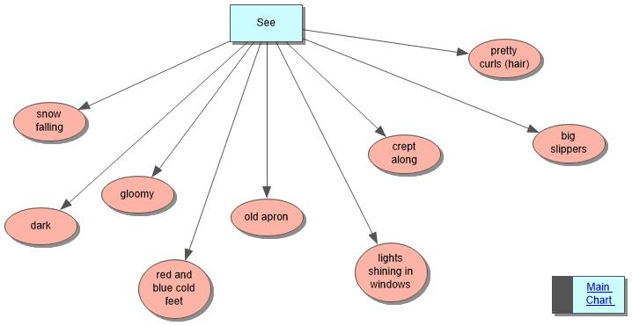

*example of what students may say are details that they “see”*

