Link to Flyer
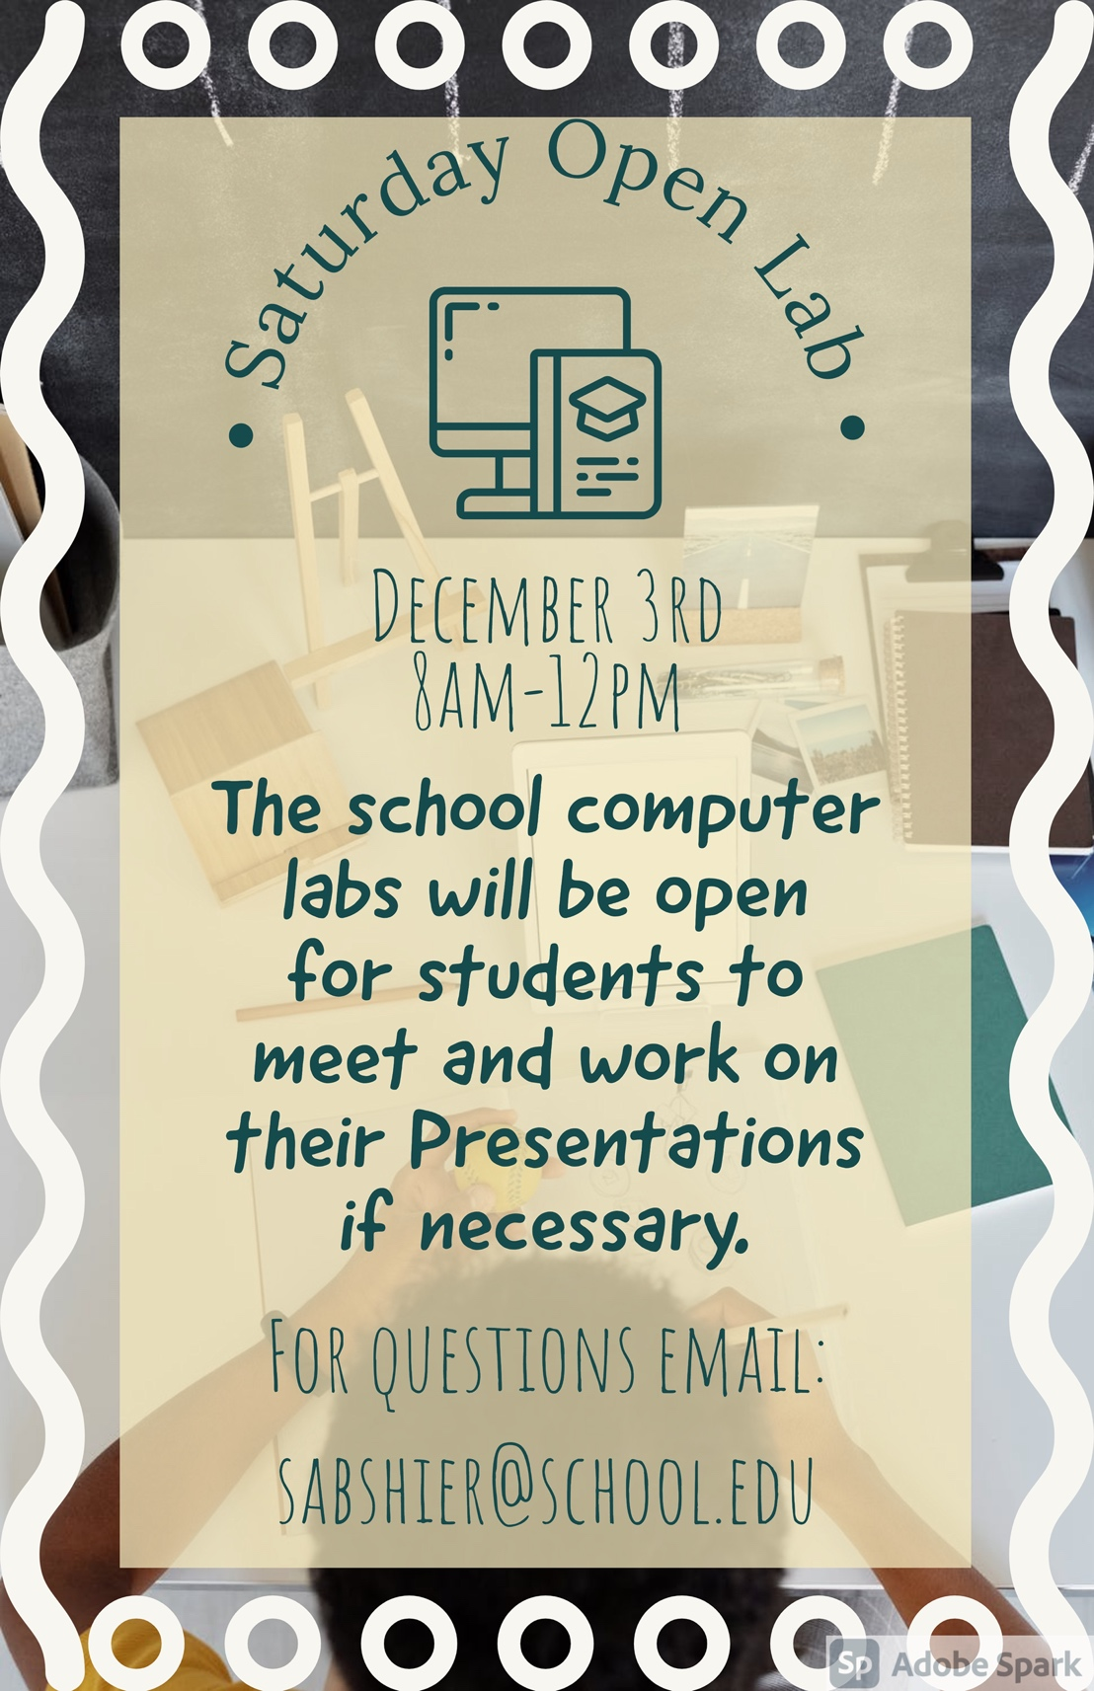

Link to Collage
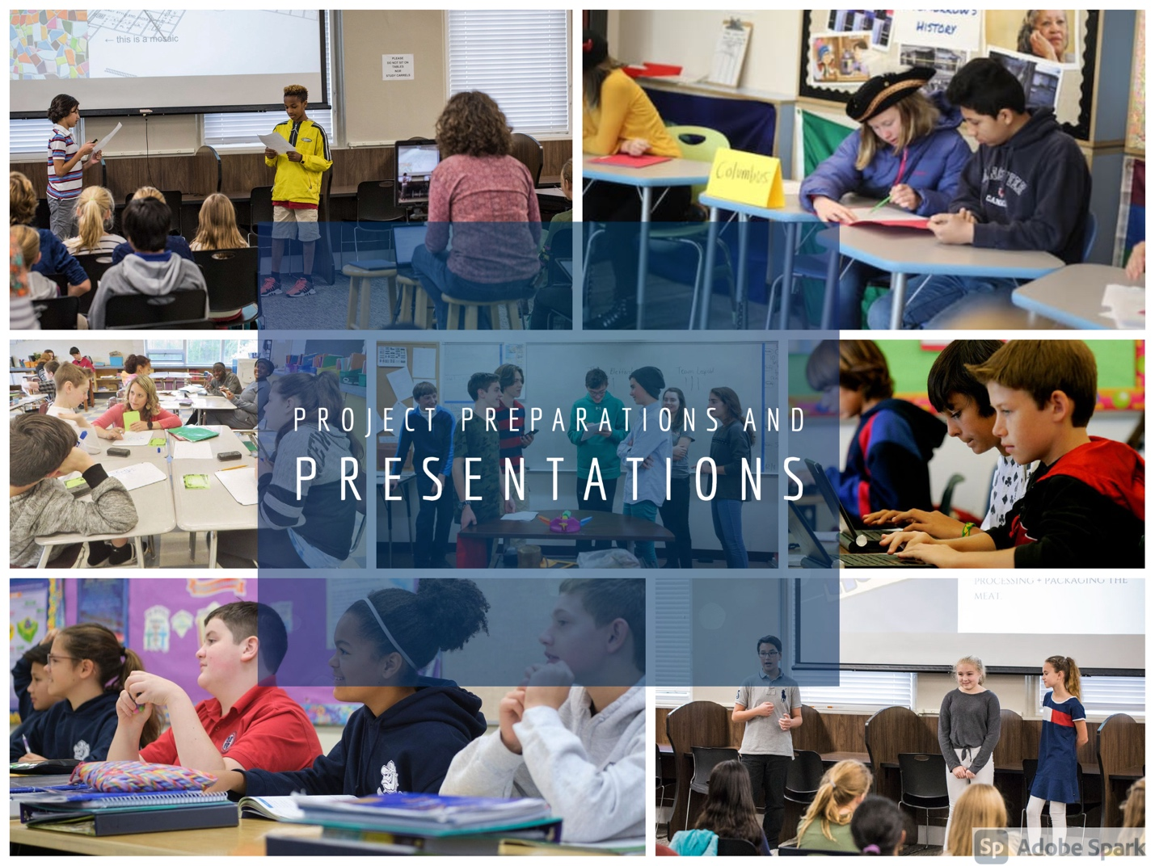
Link to Doc Newsletter

Link to Doc Newsletter Explanation

Link to Sheets Activity

Link to Sheets Lesson Plan

