**Math**

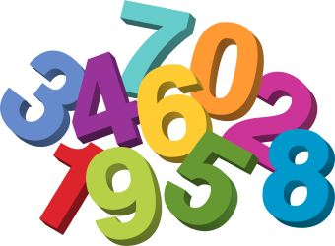

[This Photo](http://www.dailyclipart.net/clipart/category/math-clip-art/) by Unknown Author is licensed under [CC BY-ND](https://creativecommons.org/licenses/by-nd/3.0/)

* Count to ten by ones
* Count to 100 by fives
* Count to 100 by tens
* Identify zero through ten
* Write numbers zero through ten

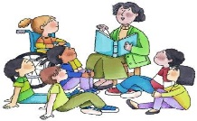

[This Photo](http://desanto.wikidot.com/10-after-reading-activities) by Unknown Author is licensed under [CC BY-SA](https://creativecommons.org/licenses/by-sa/3.0/)

**Reading**

* Understanding some concepts of print (front/back of book, where to start reading, etc.)
* Identifies upper and lower-case letters
* Practices phonemic awareness skill
* Identify letter sounds
* Retell stories

**Graded papers & Report Cards**

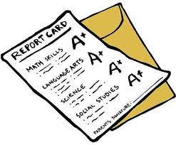

[This Photo](http://unicornexpressmhs.wordpress.com/2012/03/11/good-grades-enough-sleep-or-a-social-life-pick-any-two/) by Unknown Author is licensed under [CC BY-SA-NC](https://creativecommons.org/licenses/by-nc-sa/3.0/)

At the beginning of the week, report cards will go home with each student. They will need to be signed and returned the next day. Graded papers for the week will be sent home Friday, the 6th. They are to be reviewed, signed, and returned.

**Birthdays**

Lillian - November 3rd

Kylee – November 5th

Michael – November 6th

**Breakfast Lunch**

|  |  |  |
| --- | --- | --- |
| **Monday** | Blueberry Muffin, Fruit, Milk | Nachos or Chicken Caesar Salad |
| **Tuesday** | Cereal Bar, string cheese, milk | Soft beef tacos or bacon chicken wrap |
| **Wednesday** | French toast sticks, fruit, milk | Popcorn chicken or Turkey deli Sup |
| **Thursday** | Pancakes, Sausage, milk | Chicken quesadilla or Lasagna |
| **Friday** | Yogurt, Graham Crackers, Milk | Turkey BLT salad or Italian Flatbread |