Acceptable Use Policy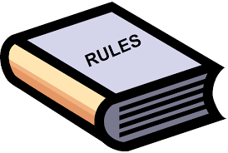

**Household Rules:**

* #1.
* #2.
* #3.
* #4.
* #5.

**Technology Rules:**

* #1.
* #2.
* #3.
* #4.
* #5.

**Chore List:**

* #1.
* #2.
* #3.
* #4.
* #5.

**Consequences:**

* #1.
* #2.
* #3.
* #4.
* #5.

By signing your name below, you acknowledge that you will follow the rules above, or face the consequences.

Child’s Name: Date:

Parent Name: Date: