**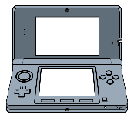****At Home Acceptable Use Policy**

(Use this chart to list devices, social media accounts, apps, usernames, passwords etc.)

|  |  |  |
| --- | --- | --- |
| Device/Account | Username | Password |
|  |  |  |
|  |  |  |
|  |  |  |
|  |  |  |
|  |  |  |
|  |  |  |

Rule 1: ____________________________________________________

__________________________________________________________

__________________________________________________________

Rule 2: ____________________________________________________

__________________________________________________________

__________________________________________________________

Rule 3: ____________________________________________________

__________________________________________________________

__________________________________________________________

Rule 4: ____________________________________________________

__________________________________________________________

__________________________________________________________

Rule 5: ____________________________________________________

__________________________________________________________

__________________________________________________________

Websites and Apps not allowed: ________________________________

______________________________________________________________________________________________________________________________________________________________________________

Screen Limit Specifications: ___________________________________  
____________________________________________________________________________________________________________________

Consequences

1. ____________________________________________________________________________________________________________
2. ____________________________________________________________________________________________________________
3. ____________________________________________________________________________________________________________
4. ____________________________________________________________________________________________________________
5. ____________________________________________________________________________________________________________

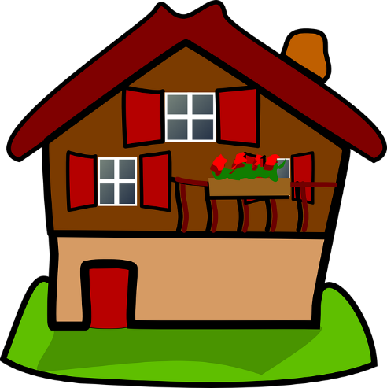Signature: _______________________________________________

Date: _______________________