Parent/Guardian,

Although it is very important to practice appropriate actions while using technology in the classroom, it is equally as important to practice these rules at home. The students should get as much exposure to what is right and what is wrong as possible. Having a list of rules such as the ones I provided for the classroom are great ways to keep structure in the household. I do not wish to change any household routine your family already has, but I have provided a template below that allows you to fill out your own rules, times, and consequences for the house. Feel free to use it however you like. My main goal is to keep the students on the same page inside and out of the classroom. Thank you so much for understanding. If you have any questions, please feel free to contact me through email.

Ms. Lolly Jennings

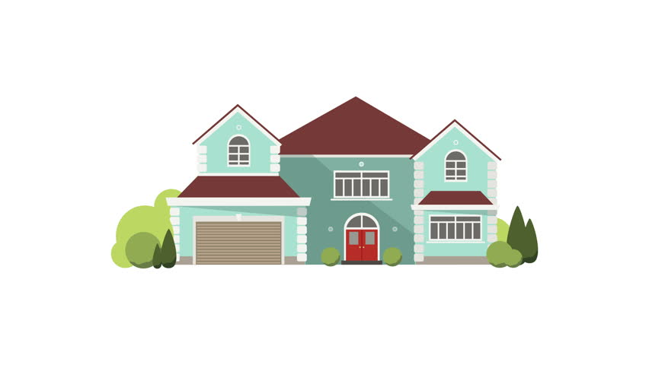

Technology Rules for Home

|  |
| --- |
|  |
|  |
|  |
|  |
|  |

Time Spent on Technology

|  |  |
| --- | --- |
| Date: | Time: |
| Date: | Time: |
| Date: | Time: |
| Date: | Time: |
| Date: | Time: |

Consequences

|  |
| --- |
| First Time: |
| Second Time: |
| Third Time: |