ACCEPTABLE USE POLICY

MS. LETICIA’S CLASSROOM

4th GRADE

Dear Parents/Guardians,

I look forward to helping your child attain many achievements this school year. As the teacher I will do my best to keep a safe and positive environment for my students. To provide the classroom with structure and order I will appreciate if you would revise my rules and expectations, with your child. Please sign and date after you and your child have read and understand all the guidelines.

Thank you!

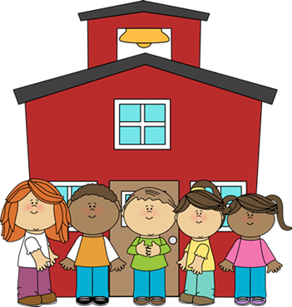

Classroom rules

* Follow instructions and listen carefully.
* Respect teachers and your fellow classmates.
* Come to class prepared.
* Ask permission before leaving your seat.
* Take care of class objects.
* Be honest and responsible.

Consequences for Breaking Rules

* Verbal warning and a talk about correcting behavior (up to 2 warnings)
* Recess time – 10 minutes deducted
* Parents/Guardians will be notified.
* If further action is needed the principle will be involved.

Electronic Devices Rules

* Personal electronic devices (such as phones) usage are not permitted unless told otherwise by teacher.
* Computers are to be used for no more than 25 minutes unless the assignment requires more time.
* No food or drinks are allowed near any electronic devices.
* Please do not travel with electronic devices unless instructed to do so. Two hands on the device or in your backpack when traveling.
* Be respectful and always take care of the devices.

Internet Rules

* Only visit teacher approved websites and applications.
* Do not download anything without permission.
* Do not share any personal information.
* Cyberbullying will not be tolerated.
* In the case of something inappropriate appearing on the screen, close or shut down the device and notify the teacher.

Consequences for Breaking rules

* A verbal warning and a talk about correcting behavior.
* Recess time – 10 minutes deducted
* Parents/Guardians will be notified.
* Privileges to use electronic devices will be taken away for the rest of the day.
* Principle will be involved.

Plagiarism

Plagiarism is using someone else’s work as your own without giving the creator any credit. When using quotes, information or pictures from a book, article, etc., we need to cite the source. Plagiarism will not be tolerated. If you are not sure how to cite a source or if you are committing plagiarism you can always ask your teacher.

Consequences

Plagiarism is a serious offense and it will be taken seriously in my classroom. The first time a student is caught committing plagiarism, he or she will be given the chance to redo the assignment. The parents/guardians will be notified of the wrongdoing. The second offense, the assignment will result in a zero and a meeting will be set up to talk with the student and the student’s parents/guardians. The third offense, the assignment will result in a zero and the parents/guardians and principle will be notified. The consequences will be decided by the principle.

Additional Information

If you have any questions about this Acceptable Use Policy or if you ever have questions about your child’s education, please feel free to contact me.

leticia.caballer@smail.astate.edu

Agreement Clause

I, _____________________, have read and agree to follow all the rules on Ms. Leticia’s Acceptable Use Policy. I understand for every rule I break there is a consequence.

Student’s signature ___________________________________ Date ____________

Parent’s/Guardian’s ___________________________________ Date ____________