October

Class Newsletter

It’s Harvest Party time!!

**It’s time for our class Harvest Party! We invite you to join us October 30, 2018 for all of the fall fun and activities! Costumes are welcome at our school this year but please nothing scary! If you bring any goodies please remember we are a nut free school!!**

September Wrap-Up

**September was a busy and exciting time in our classroom! We have learned about:**

**Science-**

**Land formations**

**Reading-**

**Asking questions about what we’ve read**

**Math-**

**Practicing place value and graphing certain word problems**

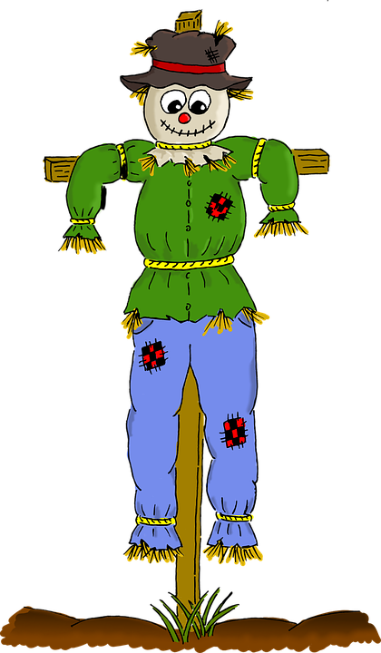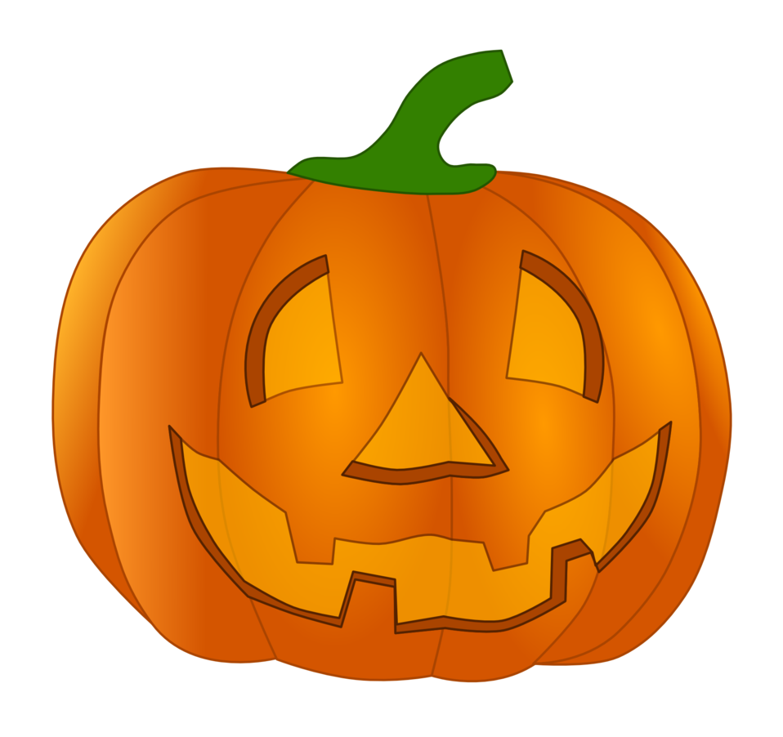

Kristen Stokes

ELED 3183

October 23.2018

Snapshot of the Week

Reading Math Science Writing Spelling

Read *The Girl* Subtraction Pumpkin Reflection Harvest

*Who Drank the* strategies oobleck journal spelling

*Moon* experiment words

Upcoming Events

It is time for our Annual Canned Food Drive! We are asking our students to bring can goods of all kinds to school to donate to Hope House. We are hoping this teaches our students the value of helping others in need! Please bring what you CAN!

Notes from the Teacher

We are working on building our class library and you can help by ordering books from our next Scholastic order! Each book you buy for your child can help our class gain points to buy more books for our classroom! Thank you!