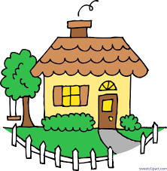

**1.__________________________________**

**2. __________________________________**

**3. __________________________________**

**4. __________________________________**

**5. __________________________________**

Household rules:

__________, I just wanted to make this document to create some rules that we need to be following in our home. These rules will be your household rules and technology/internet rules. Just like you have at school!

**Our House Rules**



Technology Rules:

1. **__________________________________**
2. **__________________________________**
3. **__________________________________**
4. **__________________________________**
5. **__________________________________**

Homework Rules:

1. **__________________________________**
2. **__________________________________**
3. **__________________________________**
4. **__________________________________**
5. **__________________________________**



Once you have read, please sign below ☺

**These rules are to keep you on track and keep you focused! It is so important to have rules in school and at home. If you follow the rules here, you will be more likely to follow them in your classroom!**

Failure to follow rule(s):

**First Offense: ______________________**

**Second Offense: ____________________**

**Third Offense: ______________________**