Home Acceptable Use Policy

I, ­________________________________ (child’s or children’s name) promise to follow all the rules of our home. I understand that failing to do so results in consequences that are listed on this agreement.

Home Basic Rules

1. I **will ­­­**_______________________________________________________.
2. I **will _______________________________________________________**.
3. I **will _______________________________________________________**.
4. I **will NOT ­­­­­­­­­­­­­­­­_________________________________________________­­_**.
5. I **will NOT** __________________________________________________.

Daily chores

1. ___________________________________________________.
2. ___________________________________________________.
3. ___________________________________________________.
4. ___________________________________________________.
5. ___________________________________________________.

Consequences

1. 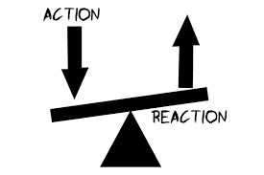____________________________________________________________.
2. ____________________________________________________________.
3. ____________________________________________________________.
4. ____________________________________________________________.
5. ____________________________________________________________.

Child (Children) _________________________________________ Date _____________

Parents/Legal Guardian _________________________________ Date _____________