Name______Kayla Johnson____________
Lesson Plan
Learning Segment Focus: _Recycling________________________Lesson ___1______of______1___

Course & topic addressed _Science and Recycling_____________Date_9/12/2020__ Grade:___K_

Student Outcomes
Specific learning objectives for this lesson. | Students will be able to sort recyclables into the correct category.
Justify how learning tasks are appropriate using examples of students’ prior academic learning. | Students have been learning to sort objects according to their size, color, and shape. This lesson will build on prior background knowledge.
Justify how learning tasks are appropriate using examples of students’ personal, cultural, linguistic, or community assets. | Students are used to seeing litter on the playgrounds and parking lots.

State Academic Content Standards
List the state academic content standards with which this lesson is aligned. Include abbreviation, number & text of the standard(s). | K-ESS3-3. Communicate solutions that will reduce the impact of humans on the land, water, air, and or other living things in the local environment.

Key Vocabulary
What vocabulary terms/content specific terminology must be addressed for students to master the content? | Recycling

Academic Language Support
What are the Academic Language Function(s) (the content and language focus of the learning task represented by the active verbs within the learning objectives/outcomes) and explain how they are utilized in the lesson plan?  What planned Academic Language Supports will you use to assist students in their understanding of key academic language to express and develop their content learning and to provide varying supports for students at different levels of Academic Language development? How do these supports address all three Academic Language Demands (vocabulary, syntax, and discourse)? | Repetition of words will help students retain information, as well as responses when asked questions about recycling. A worksheet will also be used.

Materials
Materials needed by teacher for this lesson. (such as books, writing materials, computers, models, colored paper, etc.) | SmartBoard , plastic bottles, paper, computer, printer, Inspiration 9 software, recycling worksheet, sorting cards, recycling video https://youtu.be/6jQ7y_qQYUA
Materials needed by students for this lesson. (computers, journals, textbook, etc.) | Paper, recycling worksheet, pencil, sorting cards

Lesson Timeline with Instructional Strategies & Learning Tasks
Amount of Time | Teaching & Learning Activities (This should be a BULLETED LIST) | Describe what YOU (teacher) will be doing and/or what STUDENTS will be doing during this part of the lesson. (This should be VERY DETAILED)
5 min. |  | Introduction:  The teacher will ask the students if they have noticed all of the trash on the playground. She will tell the students that all of the trash on the playground hurts our environment. The teacher will tell the students that they are going to be learning about recycling today. She will then tell the students that the trash we have can be recycled and turned into something new.
25-30 min. |  | Instruction:  The teacher will tell the students that recycling is a way to reduce the amount of garbage that is thrown away. The teacher will then tell the students that some things that would have been thrown away are reused and made into something new when we recycle. Then the teacher will show the students a video on recycling. The teacher will use a graphic organizer created using Inspiration 9 software to demonstrate how each material is sorted into a particular category to be recycled. The teacher will pass out sorting cards to each student and will be instructed to sort the items on the cards into categories. The categories will be paper, plastic, metal, and glass. When the students have finished sorting the cards the teacher will collect the cards. The teacher will ask the students questions about recycling. The teacher will then pass out the recycling worksheet to the students. The teacher will walk around and offer help to those who may need it. The teacher will collect the worksheet from the students.  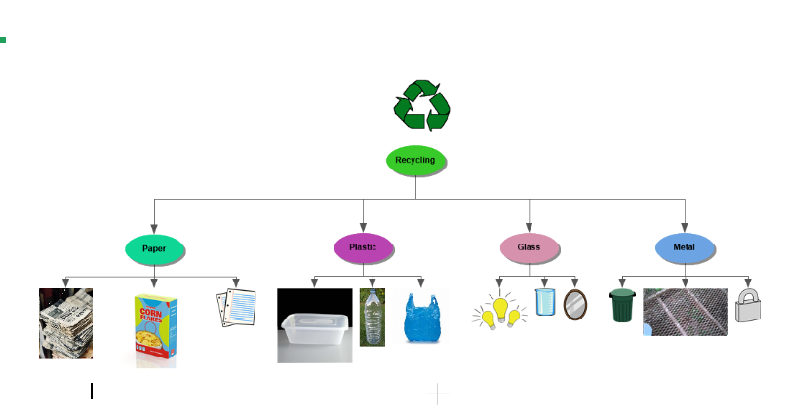
5 min. |  | Closure:  The teacher will go over what it means to recycle and the types of materials that can be recycled as a quick review.

Accommodations/Modifications
How might I modify instruction for:  Remediation?  Intervention?  IEP/504?  LEP/ESL?  (All students who have plans mandated by federal and state law.) | Modifications will be made according to a student’s IEP and 504. I will place students that have a firm understanding in groups with students who have a lower understanding. I will also off one on one to each student that needs further instruction at my table.

Differentiation
How might you provide a variety of techniques (enhanced scaffolding, explicit instruction, contextualized materials, highlighters/color coding, etc.) to ensure all student needs are met?  (All students who are not on specific plans mandated by federal and state law.) | Visual: Move the students to the front of the classroom or use larger print on worksheets.  Tactile: Use of sorting cards.

Assessments: Formative and/or Summative
Describe the tools/procedures that will be used in this lesson to monitor students’ learning of the lesson objective(s) (include type of assessment & what is assessed). | X☐ Formative /☐ Summative | Observation of facial expressions and questioning
 | X☐ Formative /☐ Summative | Collection of student’s worksheets
 | ☐ Formative /☐ Summative

Research/Theory
Explain connections to theories and/or research (as well as experts in the field or national organization positions) that support the approach you chose and justify your choices using principles of the connected theories and/or research.

Lesson Reflection/Evaluation
What went well?  What changes should be made?  How will I use assessment data for next steps? | TO BE FILLED IN AFTER TEACHING

Include supporting material such as slides, pictures, copy of textbook, and handouts for any activities students will be using as part of your lesson.

*adapted from: http://webcache.googleusercontent.com/search?q=cache:EsQcNWuG1ZoJ:web.mnstate.edu/harms/StudentTeachers/edTPA-LessonPlan.doc+&cd=2&hl=en&ct=clnk&gl=us; http://www.moreheadstate.edu/getmedia/cd3fd026-939f-4a47-a938-29c06d74ca01/Lesson-Plan-and-Reflections.aspx; http://www.mcneese.edu/f/c/9cb690d2/Lesson%20Plan%20Rubric%20Aligned%20with%20InTASC.docx;https://www.uwsp.edu/education/Documents/edTPA/Resource12.pdf; https://www.uwsp.edu/education/Documents/edTPA/Resource11.pdf; https://www.uwsp.edu/education/Documents/edTPA/Resource11a.pdf; https://www.uwsp.edu/education/Documents/edTPA/LessonPlanTemplateSOE.docx; https://www.uwsp.edu/education/Documents/edTPA/SpecEdLessonPlanGuide.docx; https://www.uwsp.edu/education/Documents/edTPA/SpecEdLessonPlanTemplate.docx

