Name___Kelsey Brooks________________
Lesson Plan Template
Lesson Segment Focus__Creating a Venn Diagram__________ Lesson ______1______of_____2_______

Course & topic addressed Comparing Apples and Pumpkins___________ Date_______________ Grade____3___

Student Outcomes

Specific learning objectives for this lesson. | The students will be learning how to create a Venn diagram. While learning how to create a Venn diagram, they are also learning the concept of comparing and contrasting two things.
Describe the connection to previous lessons. (Prior knowledge of students this builds upon) | The ideas of comparing and contrasting is knowledge the students already have, but they have not applied it in this manner.
Knowledge of students background (personal, cultural, or community assets) | There is no background information.

State Academic Content Standards

List the state academic content standards with which this lesson is aligned. Include state abbreviation and number & text of the standard.

Academic Language Support
What planned instructional supports might you use to assist students to understand key academic language to express and develop their content learning?  What will you do to provide varying supports for students at different levels of academic language development? | To help identify these new words to the students I will ask questions to see if they have any background knowledge on the words being used for our Venn diagram. Then I would bring out a large piece of notebook paper to write the new words and write the definitions with the words.

Key Vocabulary
What vocabulary terms/content specific terminology must be addressed for students to master the lesson? | Differences, similarities,

Materials

Materials needed by teacher for this lesson. | A Venn diagram printed out for each student, a large piece of notebook paper to write down definitions for the new vocabulary words, pictures of an apple and pumpkin, markers, and inspiration to create Venn diagram on screen for students to see.
Materials needed by students for this lesson. | All the students will need is a pencil and pen to fill out the Venn diagram given to them.

Lesson Timeline with Instructional Strategies & Learning Tasks (This should be VERY DETAILED)

Amount of Time | Teaching & Learning Activities | Describe what YOU (teacher) will be doing and/or what STUDENTS will be doing during this part of the lesson.
15 minutes | Introduction: | For the introduction, I will be start by asking the students what they know about apples and pumpkins. After I will ask the students if they know what a Venn diagram is, however I will assume that they do not know what this is and I will be asking just for an introduction to the topic. To introduce this, I will open up Inspiration that has a blank Venn diagram. While the children are watching I will begin to fill in the missing labels on the Venn diagram. Then I will open the discussion about what details are placed in the Venn diagram
25 minutes | Instruction: | After labeling the Venn diagram on the screen I will hand out to the students their own personal Venn diagrams and instruct them how we are going to fill in the information together. During this time, I will explain how the objects (apples and pumpkins) have their own sides and how the middle part is for the things that are similar. I will then call on the students while prompting them with questions about the things that are different between apples and pumpkins. After each response I will begin to write down each response into the appropriate sides of the Venn diagram. After each side has a good amount of answers we will repeat the process but answer questions how they are similar.  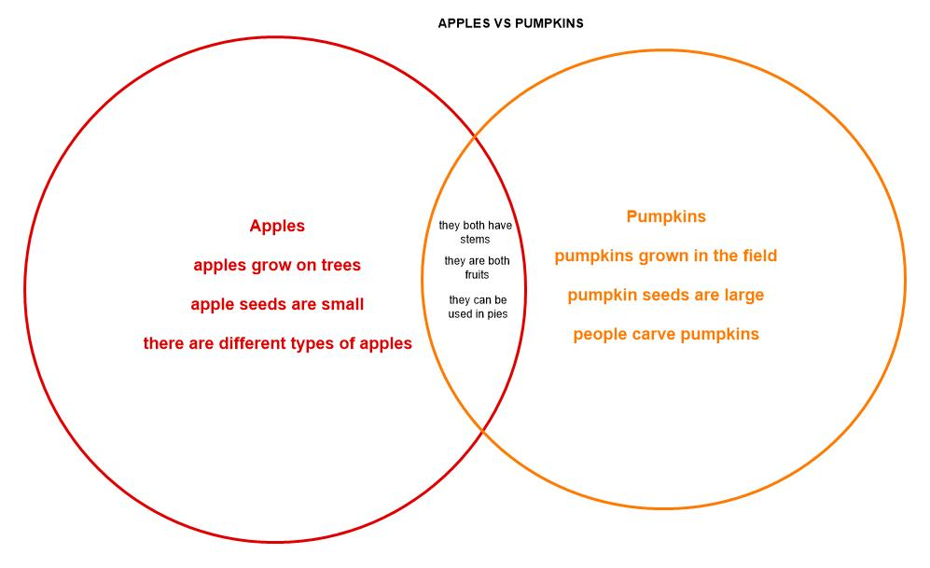
5 | Closure: | After completing the Venn diagram together, I will allow the students to be able to color in the different sides of the Venn diagram in coordination of the different objects

Accommodations/Modifications
How might I modify instruction for:

Remediation?
Intervention?
IEP/504?
LEP/ESL?

Differentiation:
How might you provide a variety of instructional methods/tasks/instructional strategies to ensure all student needs are met?

Assessments: Formative and/or Summative
Describe the tools/procedures that will be used in this lesson to monitor students’ learning of the lesson objective/s (include type of assessment & what is assessed). | ☐ Formative /☐ Summative
 | ☐ Formative /☐ Summative
 | ☐ Formative /☐ Summative

Research/Theory
Identify theories or research that supports the approach you used.

Lesson Reflection/Evaluation
What went well?  What changes should be made?  How will I use assessment data for next steps? | TO BE FILLED IN AFTER TEACHING

Include supporting material such as slides, pictures, copy of textbook, and handouts for any activities students will be using as part of your lesson.

*adapted from: http://webcache.googleusercontent.com/search?q=cache:EsQcNWuG1ZoJ:web.mnstate.edu/harms/StudentTeachers/edTPA-LessonPlan.doc+&cd=2&hl=en&ct=clnk&gl=us; http://www.moreheadstate.edu/getmedia/cd3fd026-939f-4a47-a938-29c06d74ca01/Lesson-Plan-and-Reflections.aspx; http://www.mcneese.edu/f/c/9cb690d2/Lesson%20Plan%20Rubric%20Aligned%20with%20InTASC.docx;https://www.uwsp.edu/education/Documents/edTPA/Resource12.pdf; https://www.uwsp.edu/education/Documents/edTPA/Resource11.pdf; https://www.uwsp.edu/education/Documents/edTPA/Resource11a.pdf; https://www.uwsp.edu/education/Documents/edTPA/LessonPlanTemplateSOE.docx; https://www.uwsp.edu/education/Documents/edTPA/SpecEdLessonPlanGuide.docx; https://www.uwsp.edu/education/Documents/edTPA/SpecEdLessonPlanTemplate.docx

