**Mrs. Little’s Weekly Newsletter**

Email: [jennifer.little@fakeschool.edu](mailto:jennifer.little@fakeschool.edu) / phone: 870-555-1234

Spelling Words

1. always
2. animal
3. any
4. ask
5. away
6. barn
7. because
8. been
9. best
10. between
11. blend
12. both
13. nothing
14. never
15. against

This Week

Monday: Read How Many Seeds in a Pumpkin

Tuesday: Design a jack-o-lantern worksheet will go home.

Wednesday: Graded paper folder will go home.

Thursday: Design a jack-o-lantern worksheet is due.

Friday: Spelling test.

Science Project Friday

* Pumpkin predictions
* Please contact me if you are willing to donate supplies or sponsor a science project.

October 5 – Oct 9

Science: lifecycle of a pumpkin

Math: greater than, less than, and equal to

Reading: character, setting, and plot

Writing: procedural writing

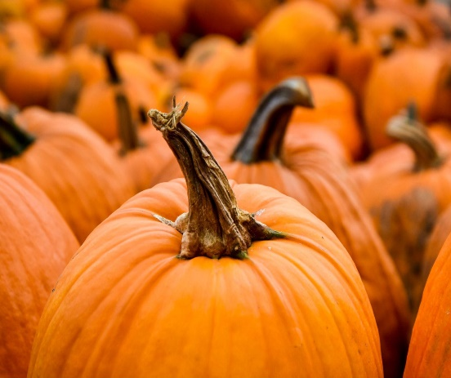

[This Photo](http://pngimg.com/download/9926) by Unknown Author is licensed under [CC BY-NC](https://creativecommons.org/licenses/by-nc/3.0/)

Reminders

* Please send empty cereal boxes by Friday, October 9th.
* Field trip to the zoo is Oct 26th.
* The 2nd grade PTO program is in the cafeteria Thursday, October 22nd at 7. Your child should wear a white t-shirt and jeans.

Read for 20 minutes each day.