Halloween Party

Dear Families,

On Thursday, October 31st, 2019 our class will be having a Halloween party at 12:00pm. There will be games, music, food, and a movie. If you would like to send something with your child, please send one of the following items:

* Cupcakes
* Juice/Water/Mini-Sodas
* Chips
* Pretzels
* 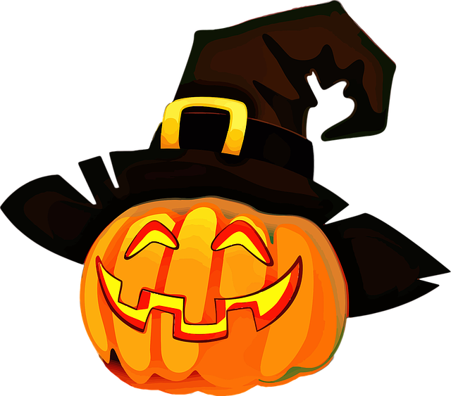Cookies

Feel free to come and join us!

Thank you,

Mrs. Jadyn