I’ve always been a daddy’s girl! Where it all began, 6th generation dancer.

Dance Team My “Mom”, or at least who I claim as my mom.

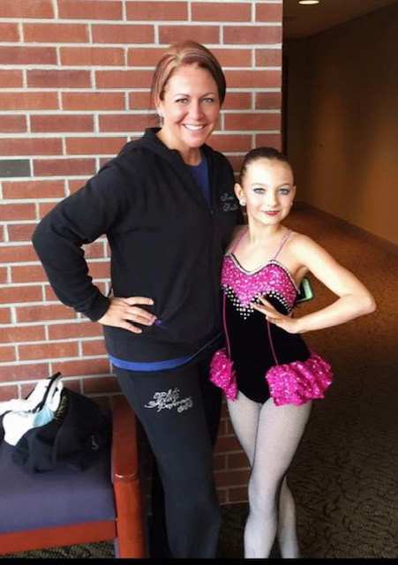

My niece Shaley. My youngest Rafferty.

My Oldest Daxton.

A couple of my dancers.

The most precious boys on the face of this earth!!!

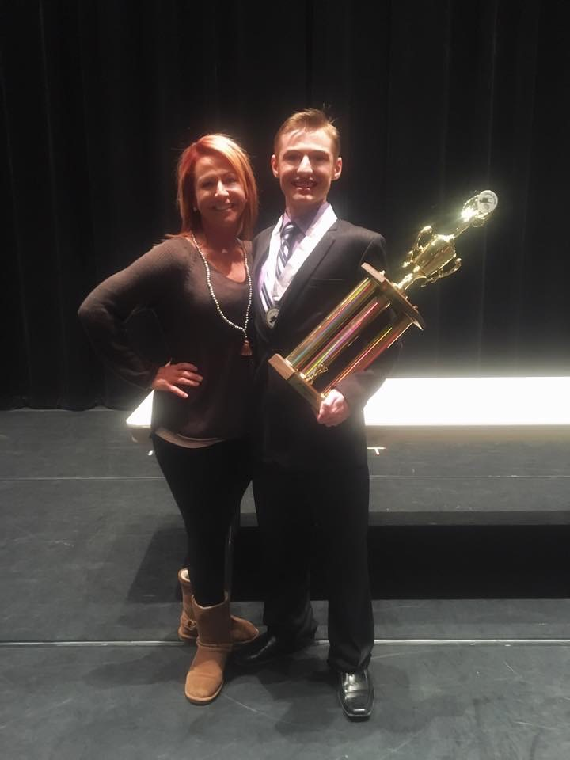

My oldest is a 7th generation dancer.

Daxton’s 1st solo.

My baby grand, Clay and Rafferty.

My dad and me. Rafferty and my Dan.

Some of my “Nutcracker” dancers.

<https://astate.yuja.com/V/Video?v=2306553&node=8321308&a=445336347&autoplay=1>