**Parent/Student Acceptable Use Policy Agreement**

**Rules for home:**

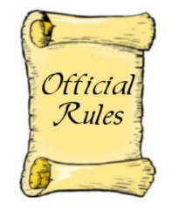1.

2.

3.

4.

5.

**Rules for using technology at home:**

1.

2.

3.

4.

5.

**Rules for using the Internet at home:**

1.

2.

3.

4.

5.

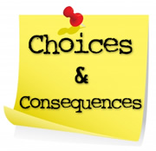  
**Consequences for breaking rules:**

1st Offense –

2nd Offense –

3rd Offense –

Student_____________________________ Date______________

Parent______________________________ Date_______________