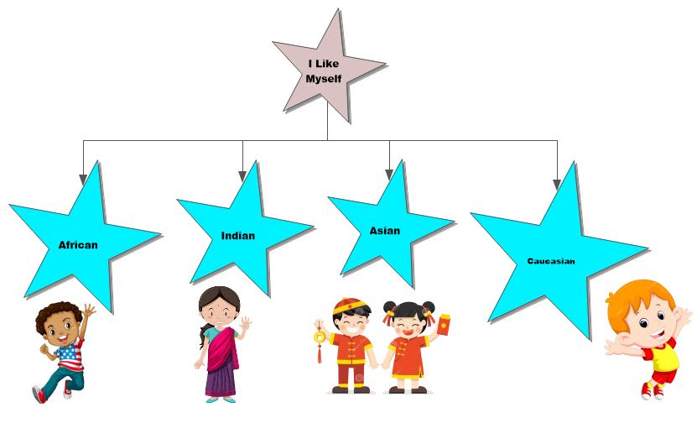

Name_Heather Benge_____________
Lesson Plan
Learning Segment Focus_Getting to Know One Another___Lesson _____1_______of_____1_______

Course & topic addressed _Writing_Getting to Know Each Other___Date_9/21/2020___ Grade___K____

Student Outcomes
Specific learning objectives for this lesson. | Introducing ourselves in the classroom and learning about our favorite book.
Justify how learning tasks are appropriate using examples of students’ prior academic learning. | Knowing their culture and where their family is from.
Justify how learning tasks are appropriate using examples of students’ personal, cultural, linguistic, or community assets. | Understanding diversity and equality in the classroom unites them as a whole.

State Academic Content Standards
List the state academic content standards with which this lesson is aligned. Include abbreviation, number & text of the standard(s). | W.K.1 -  Use a combination of drawing, dictating, and writing to compose opinion pieces in which they tell a reader the topic or the name of the book they are writing about and state an opinion or preference about the topic or book (e.g., My favorite book is...).

Key Vocabulary
What vocabulary terms/content specific terminology must be addressed for students to master the content? | Same  Different  Equal  Diverse

Academic Language Support
What are the Academic Language Function(s) (the content and language focus of the learning task represented by the active verbs within the learning objectives/outcomes) and explain how they are utilized in the lesson plan?  What planned Academic Language Supports will you use to assist students in their understanding of key academic language to express and develop their content learning and to provide varying supports for students at different levels of Academic Language development? How do these supports address all three Academic Language Demands (vocabulary, syntax, and discourse)? | I will have a map or globe as a reference to show where we have come from and where we all are now.  I would like the focus to be how we are all different yet equal.  Learning and beginning to understand different cultures at a young age fosters equality amongst peers without discrimination.

Materials
Materials needed by teacher for this lesson. (such as books, writing materials, computers, models, colored paper, etc.) | Globe, Book: Exclamation Mark by Amy Krouse Rosenthal, ball, oval paper shapes, different hues of yarn
Materials needed by students for this lesson. (computers, journals, textbook, etc.) | Crayons, glue stick, a recent picture of their face, blank sheet of paper, pencil and listening ears

Lesson Timeline with Instructional Strategies & Learning Tasks
Amount of Time | Teaching & Learning Activities (This should be a BULLETED LIST) | Describe what YOU (teacher) will be doing and/or what STUDENTS will be doing during this part of the lesson. (This should be VERY DETAILED)
5-15 min | Introduction:  - Begin lesson | I will begin by having students sit in a circle around the carpet. I will hold the ball and explain to the students that they will be introducing themselves to the other students by telling their name, where they are from and stating their favorite book.  We will use the globe to indicate where each child is from. It would be especially neat if they knew where their heritage came from. This could be accomplished by sending of survey home to their parents as an optional addition to the project.
30-35 min | Instruction:  - Reading of the book  - Ball throwing intro  - Creative activity | The students listen on the carpeted area.  The students and I will throw the ball to each and every student to learn their names, where they are from and their favorite book.  Each student will then take their glue stick to glue their picture on the blank sheet of paper. They will take the yarn of their hair color to glue around the picture as their hair. They will then compose a three-word sentence on how they like themselves.  “I am _________”
5-10 min | Closure:  - I will ask the children if they learned something new about each other.  - Putting away materials and making sure their desk is clear of clutter. | Students will turn in their project to dry so that they may be displayed to show the diversity within our classroom.

Accommodations/Modifications
How might I modify instruction for:  Remediation?  Intervention?  IEP/504?  LEP/ESL?  (All students who have plans mandated by federal and state law.) | If a child has trouble seeing or hearing, I could move them closer to me.  I will walk around the classroom throughout the project.  If a student is having issues, I could help them with a little one on one time.  If a child has difficulty cutting, I could offer assistance.

Differentiation
How might you provide a variety of techniques (enhanced scaffolding, explicit instruction, contextualized materials, highlighters/color coding, etc.) to ensure all student needs are met?  (All students who are not on specific plans mandated by federal and state law.) | Instead of using a bouncy ball, I could use a large cotton ball or balloon for safety.  We can organize by location where we are from to see if we have any similarities.  This will also show our differences.  If students struggle with writing, I could use a highlighter for them to trace over best helping them form their letters.

Assessments: Formative and/or Summative
Describe the tools/procedures that will be used in this lesson to monitor students’ learning of the lesson objective(s) (include type of assessment & what is assessed). | ☐ Formative /☐ Summative | Students will be allowed to ask questions throughout the project.
 | ☐ Formative /☐ Summative | When discussing countries, I could help students research little tidbits about their background.
 | ☐ Formative /☐ Summative | This will show diversity and equality in our classroom.

Research/Theory
Explain connections to theories and/or research (as well as experts in the field or national organization positions) that support the approach you chose and justify your choices using principles of the connected theories and/or research. | Children who learn about each other and understand different cultures at a younger age seem to have less difficulty understanding and appreciating one's heritage.  With this project we will learn something about each other and be able to see their writing ability on a kindergarten level.

Lesson Reflection/Evaluation
What went well?  What changes should be made?  How will I use assessment data for next steps? | TO BE FILLED IN AFTER TEACHING

