Classroom rules

[This Photo](http://deekayrites.blogspot.com/2011/04/flights-of-fantasy-part-3.html) by Unknown Author is licensed under [CC BY](https://creativecommons.org/licenses/by/3.0/)

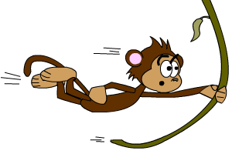

1. Keep your hands and feet to yourself
2. Follow directions
3. Listen when others are speaking
4. Throw away your trash
5. Be nice to each other

Computer “No-No’s”

1. Do NOT share personal information
2. Do NOT click on any popups or adds
3. Do NOT download without permission
4. Do NOT cyberbully
5. Do NOT steal or damage other people’s properties

Consequences

1. Verbal warning
2. Call home to parent
3. Principal

Parent Signature:

Technology Rules

1. Stay safe
2. Watch where you click
3. Ask before you use the computers
4. Wash hands before and after using the computers
5. No food or drink by any electronic device

*Always give credit when using someone else’s words, pictures, and/or music.

*Respect copywrite

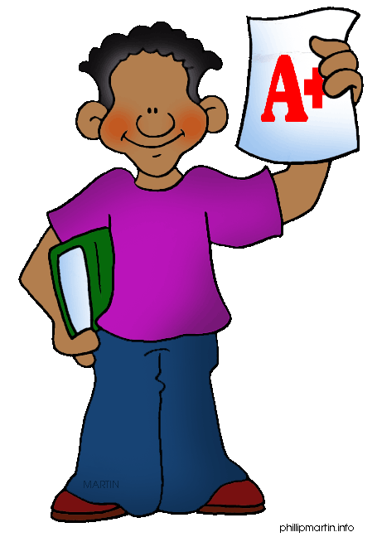

Student Signature: