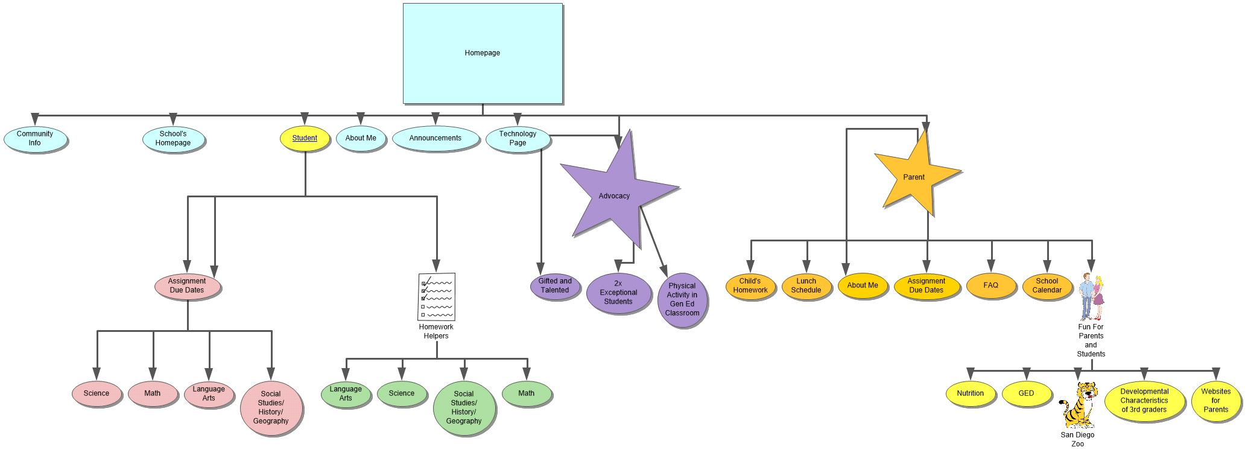

Homepage
I. Student
A. Homework Helpers
1. Language Arts
2. Science
3. Social Studies/History/Geography
4. Math
B. Assignment Due Dates
1. Science
2. Math
3. Language Arts
4. Social Studies/History/Geography
II. Community Info
III. School's Homepage
IV. About Me
V. Announcements
VI. Technology Page
VII. Advocacy
A. Gifted and Talented
B. 2x Exceptional Students
C. Physical Activity in Gen Ed Classroom
VIII. Parent
A. Child's Homework
B. Lunch Schedule
C. About Me
D. Assignment Due Dates
E. FAQ
F. School Calendar
G. Fun For Parents and Students
1. Nutrition
2. GED
3. Developmental Characteristics of 3rd graders
4. Websites for Parents
5. San Diego Zoo

