Lesson Plan Idea Format

Grade Level & Subject Area: First Grade / Reading
Standards/Framework (State Standards, Content Standards, InTASC Standards)
Arkansas State First Grade Language Arts Standards:
RL.1.1 Ask and answer questions and key details in a text.
RL.1.2 Retell stories, including key details and demonstrate understanding of the central message.
RL1.4 Identify words and phrases in stories about feelings or senses
Rl1.2 Identify the main topic
Rl1.4 Ask and answer questions to help determine or clarify the meaning of the text
Theme/Series of Lessons (if Not applicable, put N/A. If it is part of a series, of lessons, tell me, give a BRIEF description of the overall and tell me where this particular lesson fits):
N/A

Time (is this a 1 day 50-minute lesson, 5 day 1 hour lesson, once a week over a month lesson….):
This will be a one time, 30-minute lesson.

What do the students already know? (This could be the Intro or they have learned information before starting this lesson):
The students already know how to find the main character of a story and they can read short stories.

Objective (What are the students’ going to accomplish):
The objective of this lesson is:
Students will- practice reading short stories as a class and to themselves.
Students will- highlight the main character in the story.
Students will- talk about the story as a whole and pull it apart.
Students will- be able to comprehend what they read and answer questions.
Students will- be able to come together with all of their information and help me make a story web/graphic organizer about our story.
Students will- learn how to work Inspirations so that they can one day do it alone.

Materials:
Pencil
Highlighter
The Snow Day story
A piece of scratch
My projector
Inspiration

Procedure:
When it is time for Reading, I will have the students get out all of their materials so that this lesson runs smoothly. They will put them aside so that they are not a distraction. I will make sure that I have “The Snow Day” (An original story I made) pulled up on my board, as well as Inspiration.
I will pass out their story and have them read it to themselves. Then, when everyone is finished, I will read it out loud. Then, I will go to the board and as we read it one more time, and I will have them highlight the name of the main character and other characters in the story. I will be highlighting them as well on the board for another visual.
Then I will begin to ask them questions about the story to get their mind rolling. Such as:
How many characters are in the story? 4
What does Tyler want to happen SO bad? Snow
Does his wish come true? Yes
Who loves snow other than Tyler? His mom
What is something Tyler did in the snow with his sister? Snowball fight
How did Tyler feel when it snowed? Excited, happy
This will help them understand and remember the text better. As they answer, I will begin to jot these things down.
Then I will open Inspiration. We will make a web/organizer to organize all of the thoughts and answers the students came up with for the story. I will have them draw as well while I am doing it on the board so that they can begin to understand how to do this alone.

Assessment (How will the students’ show you that the objective has been met):
(Note: the assessment does not have to be a paper and pencil test)
I think that through them answering the comprehensive questions about the text will show me how much they learned, but also taking up their webs will give me a good understanding of how well they “got” it.

A Brief Description of The Entire Lesson - Plus Any Additional Information to be Included:
This will be a simple, yet effective lesson on the comprehension and dissection of a short story for First graders. They will find the main character. They will organize all of their thoughts in a graphic organizer so that one day they can create their own when reading a text or trying to come up with ideas.
The reason I came up with this assignment, was because when I was little, I LOVED short stories and I LOVED making webs of all my thoughts about a text. It made me love reading and I hope this will be the case for my students.

The Snow Day

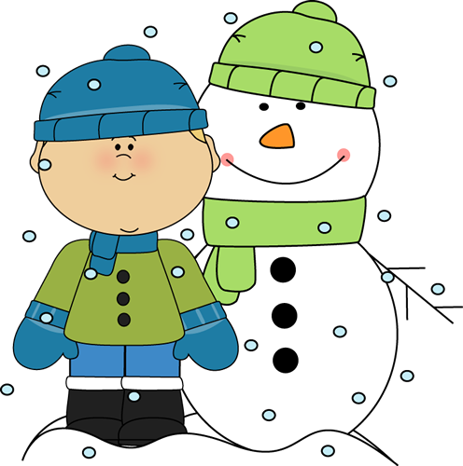
Tyler’s mom loves the snow. But Tyler had never seen snow before.

That night when Tyler went to bed, he prayed that there would be snow when he woke up.

The next morning, he ran to look out of the window. There was snow everywhere! It looked so fluffy. He got dressed and ran to play.
Tyler built a snowman, went sledding and had a snowball fight with his sister. It was the best snow day ever.

