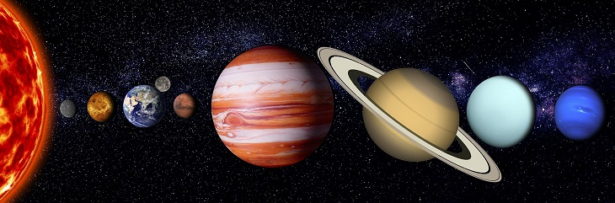
Observation of the solar system
Ms. Emily’s Lesson Plan From scratch

Arkansas First Grade Science Standards-
1-ESS1-1 Use observations of the sun, moon, and stars to describe patterns that can be predicted.
1-ESS1-2 Make observations at different times of year to relate the amount of daylight to the time of year.
ESS1.A: The Universe and its Stars- Patterns of the motion of the sun, moon, and stars in the sky can be observed, described, and predicted. (1-ESS1-1)
ESS1.B: Earth and the Solar System- Seasonal patterns of sunrise and sunset can be observed, described, and predicted. (1-ESS1-2)

Objectives for this Lesson-
Students will- Observe the planets
Students will- Compare and contrast the planets
Students will- Collect data and help me organize them on a graphic organizer
Students will- observe the solar system and answer questions from their observations

Lesson “Plan”-
Because Science is just beginning to be introduced in the First Grade, we only have Science learning time a couple of days a week. So, when this time comes, it is special, and the kids love it!

In this Lesson Plan, I will be introducing the Solar System! I will use Hubblesite.org to show them images of the Solar System, galaxies and stars to introduce the lesson. Then, I will get on space.place.nasa.gov to explore with them in more depth. On the board I will begin to write down observations about each planet that we find. Such as, the size, texture, name, where it is in the solar system. We will answer questions like:

- Based on their location compared to the sun, which planet do you think is the coldest? Which one is the warmest?
- How many planets are there in the solar system?
- What do you think the ring around Saturn is made from?
- What is a moon? Which planet has the most moons?
- Why isn’t Pluto included in the solar system? What is Pluto?
- Which planet takes the longest time to orbit around the sun?
- Which planet takes the shortest time to orbit around the sun?
- Which planet besides Earth is your favorite and why?

Then, I will introduce them to Inspiration. We will categorize what we found about each planet in a fun, unique, organized way. For them to better understand and compare the sizes of the planets, we will visually create the planets sizes in the graphic organizer as a fun part of the lesson.

Lesson time-
1 hour

Materials-
Inspiration
Hubblesite.org
space.place.nasa.gov

At the end of the lesson, I will hand each child a slip of paper numbered 1-3. I will read each question and have each student briefly answer it so that I can see if this lesson was effective and what I could change for next time.

- Tell me 1 thing you learned about the Solar System today.
- Did the graphic organizer we made help you understand better?
- What was your favorite part about today’s Science lesson?

