Home Acceptable Use Policy

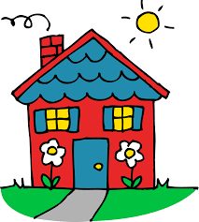I highly persuade you to create your own AUP as a family for your own home! However, this is just a suggestion. An Acceptable Use Policy holds your child to responsibilities and pushes them to **want** to meet those responsibilities. I even suggest that you allow them to make a few rules themselves. Sometimes, they come up with rules that we don’t, and most children know where they mess up and want to improve. Also, when children are held to standards at home, it helps us teachers use the most of our time to teach, rather than discipline and go over rules.

I know that for some of you, it can be scary to simply start from scratch. I am providing you with a template to begin your Home AUP and make it your own. You can change it however you like, or totally start from scratch. This is a tool simply to help you. Thank you for considering making an AUP for your home.