**Lesson Plan Idea Format**

**Grade Level & Subject Area: Grade 4 Math**

**Standards/Framework (State Standards, Content Standards, InTASC Standards)**

AR.Math.Content.4.NBT.A.1 Recognize that in a multi-digit whole number, a digit in one place represents ten times what it represents in the place to its right.

AR.Math.Content.4.NBT.A.2 Read and write multi-digit whole numbers using base-ten numerals, number names, and expanded form. Compare two multi-digit numbers based on meanings of the digits in each place, using symbols (>, =, <) to record the results of comparisons.

**Theme/Series of Lessons (if Not applicable, put N/A. If it is part of a series, of lessons, tell me, give a BRIEF description of the overall and tell me where this particular lesson fits):** N/A

**Time (is this a 1 day 50 minute lesson, 5 day 1 hour lesson, once a week over a month lesson….):**

This is a 1 day 75 minute lesson.

**What do the students already know? (This could be the Intro or they have learned information before starting this lesson):**

The students already know how to read numbers. They already know how to add, multiply, subtract and divide, which means they have an understanding of how the base 10 system works. They already know how to represent numbers by using base 10 blocks.

**Objective (What are the students’ going to accomplish):**

The student will be able to, when given a number, write it in standard form, word form, expanded form, and place value list form, and model it with base 10 blocks. Students will understand that all of the above are ways to express the same value.

**Materials:** Worksheet with several numbers listed and a place to write out each form, pencil, computer, computer, base 10 blocks, inspiration graphic explaining how to use each form (below)

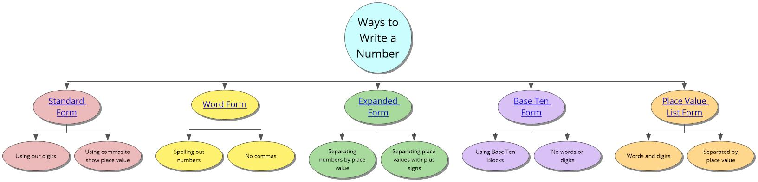

**Procedure:**

1. I will ask the students how many ways there are to write a number. Let a few students guess.
2. Give them access to the inspiration file and tell them to decide how many ways there are to write a number.
3. Give them 10-15 minutes to look over the inspiration.
4. Divide them into small groups (3 or 4).
5. Pass out the worksheet and base 10 blocks.
6. Have them work together to write each number listed in all of the different ways they explored.
7. Walk around and observe/help as needed.
8. Gather the class to discuss the answers they got.
9. Have groups share their answers with the class.
10. See if other groups agree/disagree.
11. If there is any disagreement, discuss until the class comes to a conclusion.
12. Gather papers.

**Assessment (How will the students’ show you that the objective has been met):**

**(Note: the assessment does not have to be a paper and pencil test)**

The worksheet that the groups turn in will be checked and graded. The material will be presented on the next quiz as well.

**A Brief Description Of The Entire Lesson - Plus Any Additional Information to be Included:**

Students will individually explore the inspiration file that explains the 5 ways to write out numbers. Then, students will work in groups on several examples in which they will have to write a given number in all 5 ways introduced in the inspiration file. After they finish, class will come together to discuss the answers they got. If there is any disagreement between groups, it will be resolved with discussion until everyone comes to the same conclusion. Then, the papers will be collected and graded. Students will be graded on their participation within the group, effort, and correctness.

**(I should be able to see and understand your entire lesson by reading this. Remember, Technology is not the lesson. It enhances the lesson)**