**Name_______Emilee Boozer_______**

**Lesson Plan**

**Learning Segment Focus_______States of Matter_______Lesson _____1______of_____2______**

**Course & topic addressed ____Solids, Liquids, and Gases___Date___9-20-2020___ Grade___2___**

**Student Outcomes**

|  |  |
| --- | --- |
| Specific learning **objectives** for this lesson. | The lesson’s objective is to teach the students in my classroom the 3 states of matter: solids, liquids, and gases. After this lesson, the students will be able to know the properties of each of the states of matter, as well as distinguishing what is a solid, liquid, or gases when they are asked to identify. |
| Justify how learning tasks are appropriate using examples of **students’ prior academic learning**. |  |
| Justify how learning tasks are appropriate using examples of **students’ personal, cultural, linguistic, or community assets**. |  |

**State Academic Content Standards**

|  |  |
| --- | --- |
| List the **state academic content standards** with which this lesson is aligned. Include abbreviation, number & text of the standard(s). | **AR 2-PS1-1 “Plan and conduct an investigation to describe amd classify different kinds of materials by their observable properties.”**  **PS1.A: Structure and Properties of Matter**  **-”Different kinds of matter exist and many of them can be either solid or liquid, depending on temperature. Matter can be classified by its observable properties.”** |

**Key Vocabulary**

|  |  |
| --- | --- |
| What **vocabulary terms/content specific terminology** must be addressed for students to master the content? | **matter, solid, liquid, gas, freezing point, melting point, boiling point, condensation, evaporation, and sublimation** |

**Academic Language Support**

|  |  |
| --- | --- |
| What are the **Academic Language Function(s)** (the content and language focus of the learning task represented by the active verbs within the learning objectives/outcomes) and explain how they are utilized in the lesson plan?  What planned **Academic Language Supports** will you use to assist students in their understanding of key academic language to express and develop their content learning and to provide varying supports for students at different levels of Academic Language development? How do these supports address all three **Academic Language Demands (vocabulary, syntax, and discourse)?** | To assist my students so that they can understand key academic learning to express and develop their content learning, I will personally work with each of my students one-on-one. I will have a specific area for my students to come to when help is needed so that I can personally work with them and do what is needed to help improve their understanding. Doing this will help my students who are at different levels of academic language development. |

**Materials**

|  |  |
| --- | --- |
| Materials needed by **teacher** for this lesson. (such as books, writing materials, computers, models, colored paper, etc.) | Computer, projector, and printer. |
| Materials needed by **students** for this lesson. (computers, journals, textbook, etc.) | Paper and pencil. |

**Lesson Timeline with Instructional Strategies & Learning Tasks**

|  |  |  |
| --- | --- | --- |
| **Amount of Time** | **Teaching & Learning Activities (This should be a BULLETED LIST)** | **Describe what YOU (teacher) will be doing and/or what STUDENTS will be doing during this part of the lesson. (This should be VERY DETAILED)** |
| 5 mins- 10 mins | **Introduction**: | To start off the lesson, I will introduce states of matter with a very informative yet easily understood video on the states of matter. |
| 20 mins- 30 mins | **Instruction:** | For the instruction, I will pull up my template that I made for the lesson:    I will then explain to my students the meaning of states of matter as well as the differences in the properties of each state of matter. I will give my students examples of each state of matter and ask them what about each of these examples makes it either a solid, liquid, or gas. |
| 15 mins- 20 mins | **Closure:** | The students will get out piece of paper and make a table label the states of matter. They will make the table have 3 columns: solids, liquids, and gases. Students will give 5 of their own examples for each of these columns. |

**Accommodations/Modifications**

|  |  |
| --- | --- |
| How might I **modify** instruction for:  *Remediation?*  *Intervention?*  *IEP/504?*  *LEP/ESL?*  (All students who have plans mandated by federal and state law.) | . |

**Differentiation**

|  |  |
| --- | --- |
| How might you provide a variety of techniques (enhanced scaffolding, explicit instruction, contextualized materials, highlighters/color coding, etc.) **to ensure all student needs are met?**  (All students who are not on specific plans mandated by federal and state law.) | **To ensure all my students needs are met I have made sure to include a couple of different learning methods in my lesson. I have included a video for my students who learn visually, and I will also go over the entire lesson orally so my auditory learners will also understand. If my students do not benefit from either than I will work one-on-one with them until they are to get an understanding that works the best for them.** |

**Assessments: Formative and/or Summative**

|  |  |  |
| --- | --- | --- |
| Describe the **tools/procedures** that will be used in this lesson to monitor students’ learning of the lesson objective(s) (include type of assessment & what is assessed). | ☐ Formative /☐ Summative |  |
| ☐ Formative /☐ Summative |  |
| ☐ Formative /☐ Summative |  |

**Research/Theory**

|  |  |
| --- | --- |
| Explain **connections to theories and/or researc**h (as well as experts in the field or national organization positions) that support the approach you chose and justify your choices using **principles of the connected theories and/or research.** |  |

**Lesson Reflection/Evaluation**

|  |  |
| --- | --- |
| What went **well**?  What **changes** should be made?  How will I **use assessment data** for next steps? | *TO BE FILLED IN AFTER TEACHING* |

Include supporting material such as slides, pictures, copy of textbook, and handouts for any activities students will be using as part of your lesson.

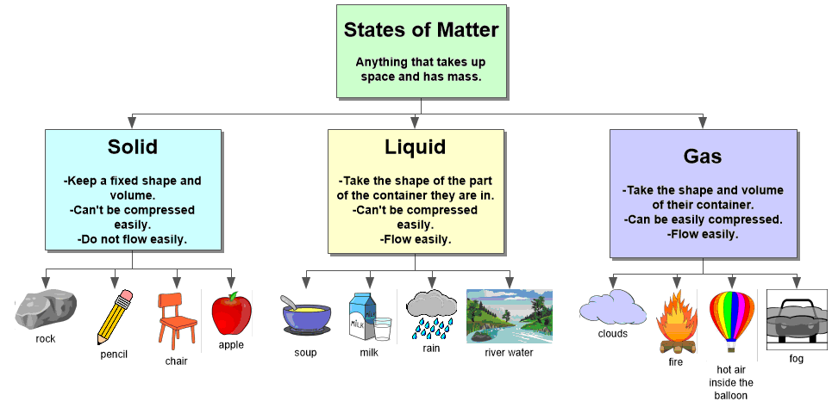

*adapted from: <http://webcache.googleusercontent.com/search?q=cache:EsQcNWuG1ZoJ:web.mnstate.edu/harms/StudentTeachers/edTPA-LessonPlan.doc+&cd=2&hl=en&ct=clnk&gl=us>; <http://www.moreheadstate.edu/getmedia/cd3fd026-939f-4a47-a938-29c06d74ca01/Lesson-Plan-and-Reflections.aspx>; <http://www.mcneese.edu/f/c/9cb690d2/Lesson%20Plan%20Rubric%20Aligned%20with%20InTASC.docx>;<https://www.uwsp.edu/education/Documents/edTPA/Resource12.pdf>; <https://www.uwsp.edu/education/Documents/edTPA/Resource11.pdf>; <https://www.uwsp.edu/education/Documents/edTPA/Resource11a.pdf>; <https://www.uwsp.edu/education/Documents/edTPA/LessonPlanTemplateSOE.docx>; <https://www.uwsp.edu/education/Documents/edTPA/SpecEdLessonPlanGuide.docx>; <https://www.uwsp.edu/education/Documents/edTPA/SpecEdLessonPlanTemplate.docx>