**Name_______Emilee Boozer_______**

**Lesson Plan**

**Learning Segment Focus_________Ecosystems___________Lesson _____2______of_____2______**

**Course & topic addressed _______Photosynthesis________Date___9-20-2020___ Grade__2____**

**Student Outcomes**

|  |  |
| --- | --- |
| Specific learning **objectives** for this lesson. | The lesson’s objective is to teach the students in my classroom on how photosynthesis works. After this lesson, my students will have an understanding on the process of photosynthesis. |
| Justify how learning tasks are appropriate using examples of **students’ prior academic learning**. |  |
| Justify how learning tasks are appropriate using examples of **students’ personal, cultural, linguistic, or community assets**. |  |

**State Academic Content Standards**

|  |  |
| --- | --- |
| List the **state academic content standards** with which this lesson is aligned. Include abbreviation, number & text of the standard(s). | **AR 2-LS2-1 “Plan and conduct an investigation to determine if plants needs sunlight and water to grow.”**  **LS2.A: Interdependent Relationships in Ecosystems**  **-”Plants depend on water and light to grow.”** |

**Key Vocabulary**

|  |  |
| --- | --- |
| What **vocabulary terms/content specific terminology** must be addressed for students to master the content? | **photosynthesis, carbon dioxide, oxygen, glucose, energy, leaves, plant, roots, and water.** |

**Academic Language Support**

|  |  |
| --- | --- |
| What are the **Academic Language Function(s)** (the content and language focus of the learning task represented by the active verbs within the learning objectives/outcomes) and explain how they are utilized in the lesson plan?  What planned **Academic Language Supports** will you use to assist students in their understanding of key academic language to express and develop their content learning and to provide varying supports for students at different levels of Academic Language development? How do these supports address all three **Academic Language Demands (vocabulary, syntax, and discourse)?** | To assist my students so that they can understand key academic learning to express and develop their content learning, I will personally work with each of my students one-on-one. I will have a specific area for my students to come to when help is needed so that I can personally work with them and do what is needed to help improve their understanding. Doing this will help my students who are at different levels of academic language development. |

**Materials**

|  |  |
| --- | --- |
| Materials needed by **teacher** for this lesson. (such as books, writing materials, computers, models, colored paper, etc.) | computer, projector, handouts for each of my students, printed out quizzes, and plant/flower. |
| Materials needed by **students** for this lesson. (computers, journals, textbook, etc.) | pencil, handout, and the piece of paper that has the quiz on it for the end of the lesson. |

**Lesson Timeline with Instructional Strategies & Learning Tasks**

|  |  |  |
| --- | --- | --- |
| **Amount of Time** | **Teaching & Learning Activities (This should be a BULLETED LIST)** | **Describe what YOU (teacher) will be doing and/or what STUDENTS will be doing during this part of the lesson. (This should be VERY DETAILED)** |
| 5 mins- 10 mins | **Introduction**: | I will start my lesson off by giving my student video explaining photosynthesis in the most simplified form to watch, so they have a basic understand of how photosynthesis works and the process a plant undergoes through photosynthesis. |
| 20 mins- 30 mins | **Instruction:** | After the video, I will give instruction on photosynthesis by giving my students each a handout like this:    The students will be able to use this handout to follow along with my teaching as I verbally explain to them how photosynthesis works. I can use this handout to ask my students questions on photosynthesis. By doing this, I will be able to see which of my students have fully understood and which students I may need to work with to help them understand more fully. I also think it would be neat to bring a plant or flower in a pot to class to keep in the window as a reminder of photosynthesis. That way in the morning when we water the plant, I can ask them to quickly review the processes of photosynthesis. |
| 10 mins- 15 mins | **Closure:** | At the end of the lesson, I will give each of my students a simple quiz review only the things that we have gone over in class to make each sure each students has an understand on photosynthesis so that I will know if we need to review a few more time or to see if we will be able to move on. |

**Accommodations/Modifications**

|  |  |
| --- | --- |
| How might I **modify** instruction for:  *Remediation?*  *Intervention?*  *IEP/504?*  *LEP/ESL?*  (All students who have plans mandated by federal and state law.) | . |

**Differentiation**

|  |  |
| --- | --- |
| How might you provide a variety of techniques (enhanced scaffolding, explicit instruction, contextualized materials, highlighters/color coding, etc.) **to ensure all student needs are met?**  (All students who are not on specific plans mandated by federal and state law.) | **To ensure all my students needs are met I have made sure to include a couple of different learning methods in my lesson. I have included a video for my students who learn visually, and I will also go over the entire lesson orally so my auditory learners will also understand. If my students do not benefit from either than I will work one-on-one with them until they are to get an understanding that works the best for them.** |

**Assessments: Formative and/or Summative**

|  |  |  |
| --- | --- | --- |
| Describe the **tools/procedures** that will be used in this lesson to monitor students’ learning of the lesson objective(s) (include type of assessment & what is assessed). | ☐ Formative /☐ Summative |  |
| ☐ Formative /☐ Summative |  |
| ☐ Formative /☐ Summative |  |

**Research/Theory**

|  |  |
| --- | --- |
| Explain **connections to theories and/or researc**h (as well as experts in the field or national organization positions) that support the approach you chose and justify your choices using **principles of the connected theories and/or research.** |  |

**Lesson Reflection/Evaluation**

|  |  |
| --- | --- |
| What went **well**?  What **changes** should be made?  How will I **use assessment data** for next steps? | *TO BE FILLED IN AFTER TEACHING* |

Include supporting material such as slides, pictures, copy of textbook, and handouts for any activities students will be using as part of your lesson.

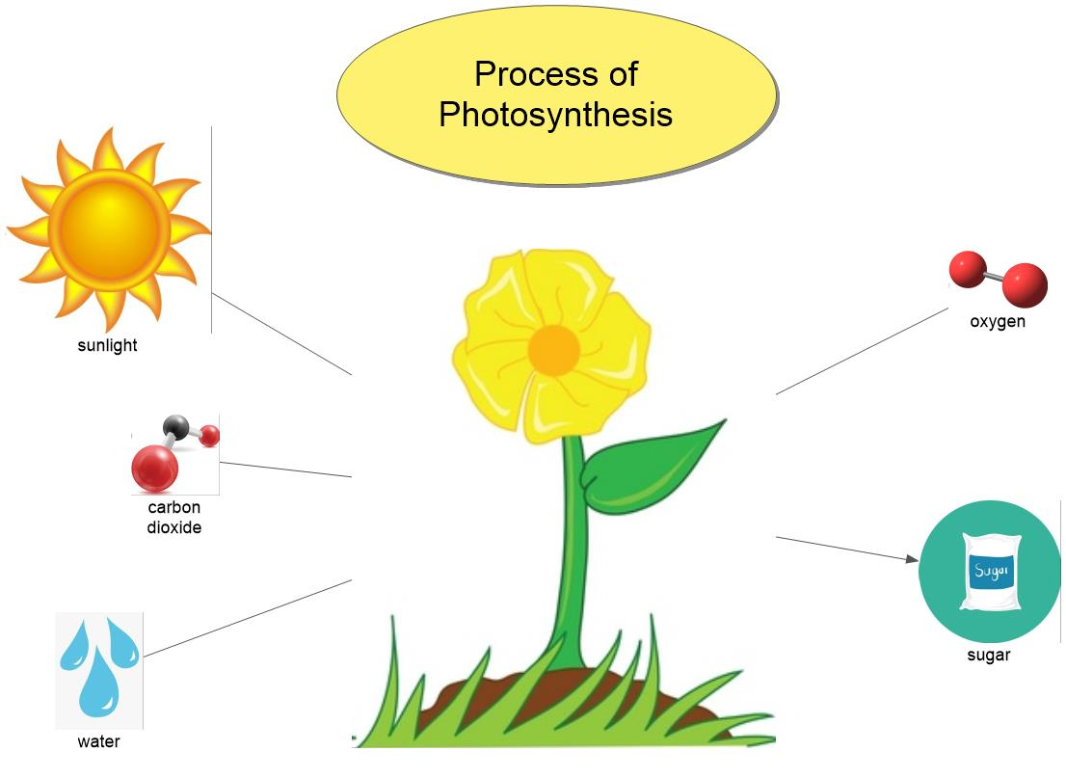

*adapted from: <http://webcache.googleusercontent.com/search?q=cache:EsQcNWuG1ZoJ:web.mnstate.edu/harms/StudentTeachers/edTPA-LessonPlan.doc+&cd=2&hl=en&ct=clnk&gl=us>; <http://www.moreheadstate.edu/getmedia/cd3fd026-939f-4a47-a938-29c06d74ca01/Lesson-Plan-and-Reflections.aspx>; <http://www.mcneese.edu/f/c/9cb690d2/Lesson%20Plan%20Rubric%20Aligned%20with%20InTASC.docx>;<https://www.uwsp.edu/education/Documents/edTPA/Resource12.pdf>; <https://www.uwsp.edu/education/Documents/edTPA/Resource11.pdf>; <https://www.uwsp.edu/education/Documents/edTPA/Resource11a.pdf>; <https://www.uwsp.edu/education/Documents/edTPA/LessonPlanTemplateSOE.docx>; <https://www.uwsp.edu/education/Documents/edTPA/SpecEdLessonPlanGuide.docx>; <https://www.uwsp.edu/education/Documents/edTPA/SpecEdLessonPlanTemplate.docx>