**Name____Chaquinn Strickland_______**

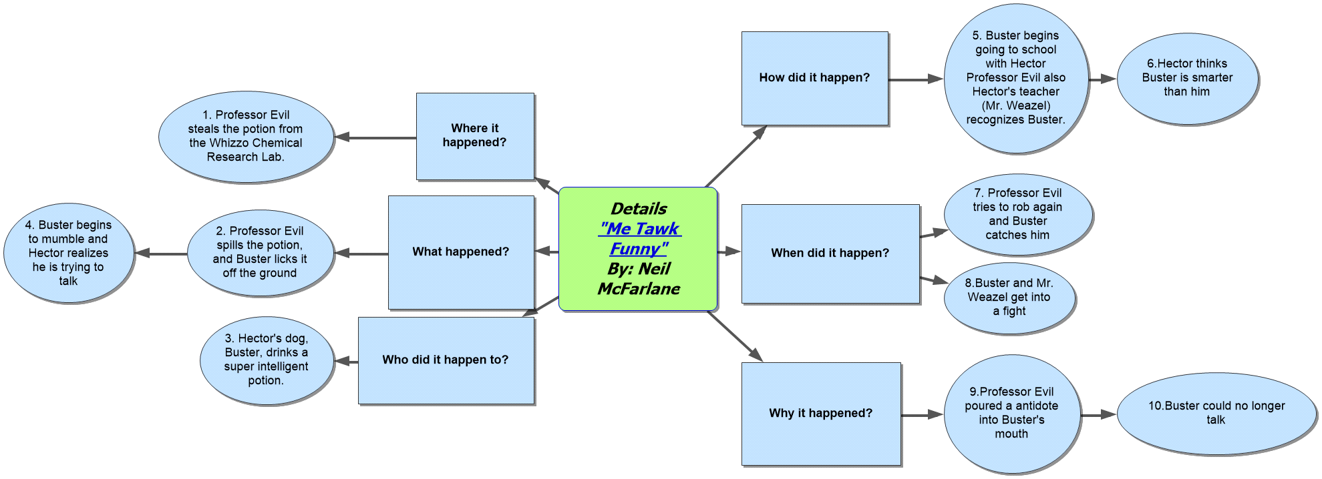

**Lesson Plan Template**

**Lesson Segment Focus___________Understanding text_________________________ Lesson 2___of___13**

**Course & topic addressed _________English: Details in a text ________________________ Date___09/04/19____ Grade___3rd____**

**Student Outcomes**

|  |  |
| --- | --- |
| Specific learning objectives for this lesson. | Teaching students how to interpret text by finding out the answers to Who, What, When, Why, Where, and How to demonstrate comprehending the text. |
| Describe the connection to previous lessons. (Prior knowledge of students this builds upon) | This lesson builds upon the students using context clues and the ability to recognize the structure of a text. |
| Knowledge of students background (personal, cultural, or community assets) | Students will be able to make predictions and provide solutions as they read in the future. |

**State Academic Content Standards**

|  |  |
| --- | --- |
| List the state academic content standards with which this lesson is aligned. Include state abbreviation and number & text of the standard. | RL.2.1 Ask and answer such questions as who, what, where, when, why, and how to demonstrate understanding of key details in a text. |

**Academic Language Support**

|  |  |
| --- | --- |
| What planned instructional supports might you use to assist students to understand key academic language to express and develop their content learning?  What will you do to provide varying supports for students at different levels of academic language development? | To assist students, I will have charts for them to fill out while they read, and we discuss the text. For students at different levels, I will explain in depth about what answers are acceptable or not. |

Key Vocabulary

|  |  |
| --- | --- |
| What vocabulary terms/content specific terminology must be addressed for students to master the lesson? | Students must know what these terms: character, plot, summary, and setting. |

Materials

|  |  |
| --- | --- |
| Materials needed by teacher for **this lesson**. | The teacher will need chart paper for the classroom’s representation of the chart, along with different color markers to represent each who, what, why, where, how, and when. |
| Materials needed by students for **this lesson**. | Students will need colored paper, and also different colored writing utensils so that they will not get confused. |

**Lesson Timeline with Instructional Strategies & Learning Tasks (This should be VERY DETAILED)**

| **Amount of Time** | **Teaching & Learning Activities** | **Describe what YOU (teacher) will be doing and/or what STUDENTS will be doing during this part of the lesson.** |
| --- | --- | --- |
| 15 mins | **Introduction**:  I will begin reading to the children a small short story. | I will begin reading to the children a small short story, letting them jot down small details that they think are important. |
| 30 mins | Instruction:  After listening to the story, I will ask the students to think about what they heard. Then I will let them read silently to themselves and circle anything that might be important to them. Then they will work as a group. | The students when will circling and highlighting the significant things to them. After reading, the students will break up into different groups. Each section will have How, Why, When, Where, and What. They will be able to discuss within their groups. After the we will fill out the classroom chart and discuss in farther detail. |
| 10 mins | **Closure:**  We will close out by going over questions that are relevant to the book. | Students will be given this time to ask any questions about the lesson and I will answer them. |

**Accommodations/Modifications**

|  |  |
| --- | --- |
| How might I modify instruction for:  Remediation?  Intervention?  IEP/504?  LEP/ESL? | I would provide extra time for those that need it. I will answer and additional questions that the students might have. If a child has a disability, their work may vary from the general students. |

**Differentiation:**

|  |  |
| --- | --- |
| How might you provide a variety of instructional methods/tasks/instructional strategies to ensure all student needs are met? | Everything will not just be pencil and paper assignments. There could be like oral assessments and technology-oriented tests. |

**Assessments: Formative and/or Summative**

|  |  |  |
| --- | --- | --- |
| Describe the tools/procedures that will be used in this lesson to monitor students’ learning of the lesson objective/s (include type of assessment & what is assessed). | ☐ Formative /☐ Summative | One procedure would be to let the students explain their charts, and this will let me know whether they understand their work and can use it as an exit ticket. |
| ☐ Formative /☐ Summative | The students will get an exam and will have to fill out their own based on a short story I will provide for them. |
| ☐ Formative /☐ Summative | Another procedure could be to compare and see what students got similar or different information for their charts, and create a classroom poll. |

**Research/Theory**

|  |  |
| --- | --- |
| Identify theories or research that supports the approach you used. | Research provided information that students learn from repetition. By the teacher reading to them, them reading to themselves they could get a better understanding. |

**Lesson Reflection/Evaluation**

|  |  |
| --- | --- |
| What went well?  What changes should be made?  How will I use assessment data for next steps? | The idea of the chart went well. Next time, the students could read the text themselves first then we discuss and read out loud, that way the student can check and see if their annotations on the chart are correct.  Assessments the next time will be verbal, cause when you are reading text, sometimes there is not right or wrong because each student can interpret something different. |

Include supporting material such as slides, pictures, copy of textbook, and handouts for any activities students will be using as part of your lesson.

*adapted from: <http://webcache.googleusercontent.com/search?q=cache:EsQcNWuG1ZoJ:web.mnstate.edu/harms/StudentTeachers/edTPA-LessonPlan.doc+&cd=2&hl=en&ct=clnk&gl=us>; <http://www.moreheadstate.edu/getmedia/cd3fd026-939f-4a47-a938-29c06d74ca01/Lesson-Plan-and-Reflections.aspx>; <http://www.mcneese.edu/f/c/9cb690d2/Lesson%20Plan%20Rubric%20Aligned%20with%20InTASC.docx>;<https://www.uwsp.edu/education/Documents/edTPA/Resource12.pdf>; <https://www.uwsp.edu/education/Documents/edTPA/Resource11.pdf>; <https://www.uwsp.edu/education/Documents/edTPA/Resource11a.pdf>; <https://www.uwsp.edu/education/Documents/edTPA/LessonPlanTemplateSOE.docx>; <https://www.uwsp.edu/education/Documents/edTPA/SpecEdLessonPlanGuide.docx>; <https://www.uwsp.edu/education/Documents/edTPA/SpecEdLessonPlanTemplate.docx>