**Lesson Plan Model[1]** 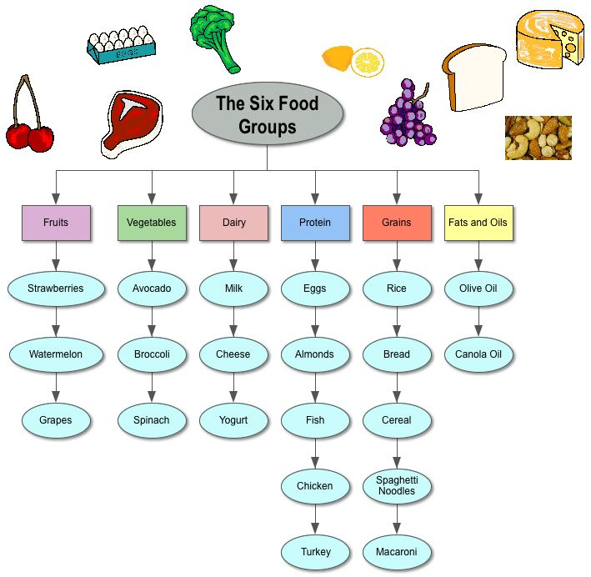

Lesson Title/#: Choosing Healthy Foods

Grade Level: 2nd grade

**Learning Central Focus**

|  |  |
| --- | --- |
| Central Focus  What is the central focus for the content in the learning segment? | The focus of this lesson is healthy choices in each food group, while being able to build a balanced plate. |
| Content Standard  What standard(s) are most relevant to the learning goals? | HW.12.2.1 Choose a healthy snack from each food group  HW.12.2.3 Identify the major nutrients:   * carbohydrates * protein * fats * vitamins * minerals * water |
| Student Learning Goal(s)/ Objective(s)  **Skills/procedures**  What are the specific learning goal(s) for student in this lesson?  **Concepts and reasoning/problem solving/thinking/strategies[2]**  What are the specific learning goal(s) for students in this lesson? | The students will be able to place each food item given in the correct food group. They will also be able to identify major nutrient in those foods and choose a healthy snack. |
| Prior Academic Knowledge and Conceptions  What knowledge, skills, and concepts must students already know to be successful with this lesson?  What prior knowledge and/or gaps in knowledge do **these** students have that are necessary to support the learning of the skills and concepts for this lesson? | The students should have a basic knowledge of each of the foods groups and of the major nutrients. This will aid the student in matching each food item to its correct food group. Students must also have knowledge of healthy and unhealthy foods. |
| Common Errors, Developmental Approximations, Misconceptions, Partial Understandings, or Misunderstandings  What are common errors or misunderstandings of students related to the central focus of this lesson?  How will you address them for **this group** of students? |  |

**Instructional Strategies and Learning Tasks**

*Description of what the teacher (you) will be doing and/or what the students will be doing.*

|  |  |
| --- | --- |
| Launch  __________ Minutes  How will you start the lesson to engage and motivate students in learning? | 5-10 minutes. First I will ask the students to share their favorite food or meal. After they’ve shared, we will discuss which food group the items belong to. |
| Instruction  __________ Minutes  What will you do to engage students in developing understanding of the lesson objective(s)?  How will you link the new content (skills and concepts) to students’ prior academic learning and their personal/cultural and community assets?  What will you say and do? What questions will you ask?  How will you engage students to help them understand the concepts?  What will students do?  How will you determine if students are meeting the intended learning objectives? | 30 minutes. I will explain each food group and then have the students name off different foods which I will type onto the screen. After we’ve named off at least 15 foods I will ask the class which food group they think each item belongs to. Then I will link the foods named with the food group the students choose. After we’ve linked each food item to the groups, we will talk about the major nutrients. We will also discuss which items are healthy and which and not. |
| Structured Practice and  Application  __________ Minutes  How will you give students the opportunity to practice so you can provide feedback?  How will students apply what they have learned?  How will you determine if students are meeting the intended learning objectives? | 30 minutes. After we’ve discussed the food groups and nutrients, I will pass out magazines and construction paper to the kids so they can cut out food and make their own plate. The students will be required to include a healthy item from each food group on their plate. |
| Closure  __________ Minutes  How will you end the lesson? | 5-10 minutes. After they’ve created their plates I will ask volunteer students to show their plate to the class. They will be require to identify the food groups on their plates along with the items they chose and why. I will also ask them which nutrients can be found in the items they chose. |
| Differentiation/ Planned Support  How will you provide students access to learning based on individual and group needs?  How will you support students with gaps in the prior knowledge that is necessary to be successful in this lesson? | *Whole Class*:  *Groups of students with similar needs*:  *Individual students*:  *Students with IEP’s or 504 plans*:  *Strategies for responding to common errors and misunderstandings, developmental approximations, misconceptions, partial understandings, and/or misunderstandings*: |
| Student Interactions  How will you structure opportunities for students to work with partners or in groups? What criteria will you use when forming groups? | After the lesson and plate craft, I will divide the students into groups by their tables. I will give them Go Fish food pyramid cards for them to play with each other. The Go Fish cards will have a food item on them and with the label of the food group. One student will deal cards and the student to their right will go first. The student can ask another student if they have a certain food group card, if that student has one they have to give it to the other person, if they don’t have the card they must tell them to “Go Fish!” The student with the most pairs wins. |
| What Ifs  What might not go as planned and how can you be ready to make adjustment? | If my students do not place the examples in the correct food category I will first ask the class why they believe it belongs to that group. Then I will explain the item’s correct place. If my students bring their plate to me but don’t include every food group I will first ask them if they included every category, then I will ask them to go find an item from the missing category to put on their plate, if they cannot find a category by themselves I will help them look or give them examples again. |
| Theoretical Principles and/or Research–Based Best Practices  Why are the learning tasks for this lesson appropriate for your students? |  |
| Materials  What materials does the teacher need for **this lesson?**  What materials do the students need for **this lesson?** | The teacher will need:  -a way to project the diagram on the wall/ board  -(plastic) examples from each food group  -Food pyramid Go Fish cards  -food magazines for the students to cut  The student will need:  -construction paper  -glue  -scissors |

**Academic Language Demand(s):**

|  |  |
| --- | --- |
| What language function do you want students to develop in this lesson? What must students understand in order to be intellectually engaged in the lesson? |  |
| What content specific terms (vocabulary) do students need to support learning of the learning objective for this lesson |  |
| What specific way(s) will students need to use language (reading, writing, listening and/or speaking) to participate in learning tasks and demonstrate their learning for this lesson? |  |
| What are your students’ abilities with regard to the oral and written language associated with this lesson? |  |
|  |  |
| How will you **support** students so they can understand and use the language associated with the language function and other demands in meeting the learning objectives of the lesson? |  |

**Assessments:**

*Describe the tools/procedures that will be used in* ***this lesson*** *to monitor students’ learning of the lesson objective(s). Attach a copy of the assessment and the evaluation criteria/rubric in the resources section at the end of the lesson plan.*

|  |  |  |  |
| --- | --- | --- | --- |
| Type of assessment  (Informal or Formal) | Description of assessment | Modifications to the assessment so that all students could demonstrate their learning. | Evaluation Criteria - What evidence of student learning (related to the learning objectives and central focus) does the assessment provide? |
|  |  |  |  |
|  |  |  |  |
|  |  |  |  |
|  |  |  |  |
|  |  |  |  |

**Analyzing Teaching**

To be completed after the lesson has be taught

|  |  |
| --- | --- |
| What worked?  What didn’t?  For whom? |  |
| Adjustments  What instructional changes do you need to make as you prepare for the lesson tomorrow? |  |
| Proposed Changes.  If you could teach this lesson again to this group of students what changes would you make to your **instruction**? | *Whole class*:  *Groups of students*:  *Individual students*: |
| Justification  Why will these changes improve student learning?  What research/ theory supports these changes? |  |

**Resources:**

Attach each assessment and associated evaluation criteria/rubric.



1. *The lesson plan template is intended to be used as a* ***formative*** *process prior to a candidate’s submission of edTPA materials. The template offers an opportunity for candidates to practice documenting their thinking when planning lessons leading up to the learning segment they will teach for edTPA. Lesson plans with this level of detail are not necessary and should not be submitted as part of edTPA. It is intended to prepare candidates to articulate their thinking and justification for plans when responding to the Planning Task commentary prompts*
2. *The prompt provided here should be modified to reflect subject specific aspects of learning. Language here is mathematics related. See candidate edTPA handbooks for the “Making Good Choices” resource for subject specific components.*