At Home Acceptable Use Policy

House Rules

1.

2.

3.

Homework Rules

1.

2.

3.

Computer and Internet Rules

1.

2.

3.

Bedtime Rules:  
1.

2.

3.

Chores:

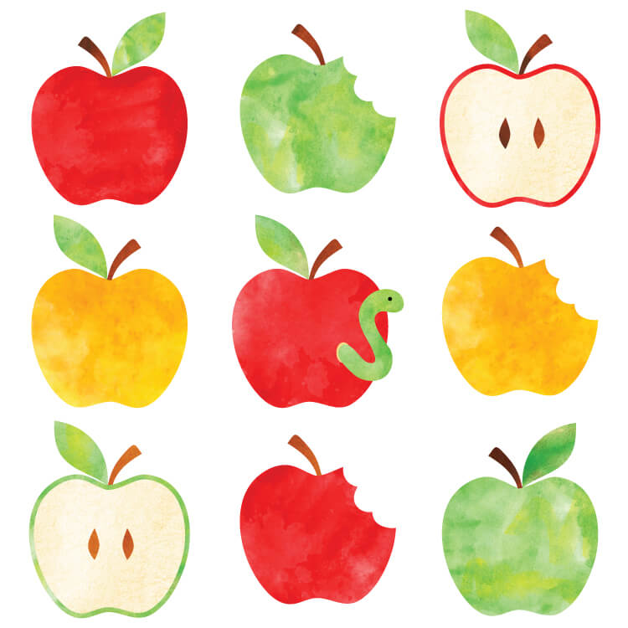1.

## 2.

3.

Consequences

**First:**

**Second:**

**Third:**



Child’s Signature: ____________________

Parent’s Signature: ____________________