**Halloween Party on October 31st**

Our class Halloween Party will be on Wednesday, October 31st. We will need parents to send one bag of candy for each student. Costumes can be worn but no face paint or masks please!

Candy Needed:

* Reese’s
* Snickers
* Kit Kats
* Skittles
* M&Ms
* Dum Dums

**Coat Closet Donations**

Our class as well as all of the elementary is now collecting coat donations for our school’s coat closet! Please consider donating old coats or coats that no longer fit your child. We have students that do not have coats to wear and the weather is getting cooler. Just send them with your children!

**New Unit in Science**

Our class is beginning a new unit this week in science and it focuses on plant life. For this we will be keeping a class plant and watching how it grows and tending to the plants needs such as watering, and sunlight.

**Parent Teacher Conference**

Parent Teacher Conferences are coming up soon!! They will be held on October 18th from 3:30pm to 8:00pm. Students will be let out at 1:30pm on the 18th to prepare for the conferences and out on the 19th for Professional Development.

**Field Trip to Pumpkin Hollow**

Our field trip to Pumpkin Hollow will be on Monday, October 22nd. We will leave the school at 8:30am and return at 2:30pm. Please have your student at the school before we leave!! Also please pack your child a sack lunch and make sure they have $5 for admission!! 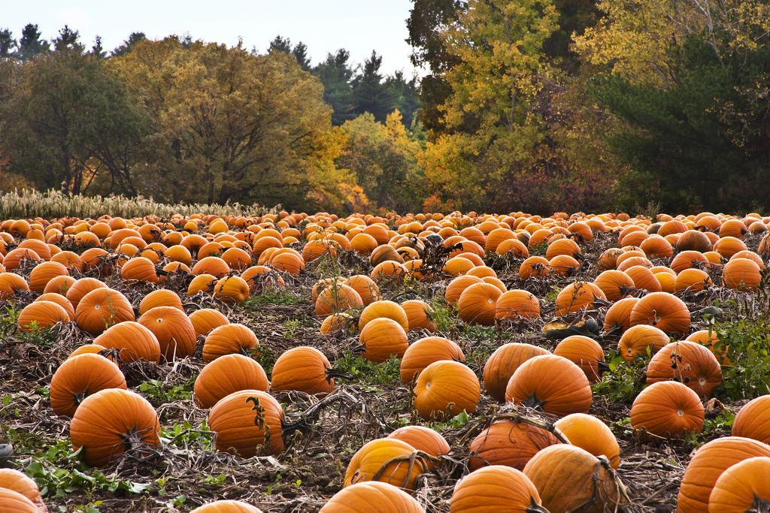

**Student of the Month**

October’s Student of the Month is Elizabeth Hay!! Her respect, hard work ethic, and attitude helped her earn this and she will receive extra recess time as well as a pizza party with the other 4th grade Student of the Months!