Cason Burk and Madison Hardin
Monday/Wednesday 12:30-1:45

Title: | Homer
Version: | 9.0
Publisher or Producer: | Neal Shenoy, he is the Co-founder and Chief of Executive Officer.  Stephanie Dua, Co-Founder and President  Noelle Millholt, Co-Founder and Chief Revenue Officer. She oversees all of HOMER’S business development
Target Audience:  (if your opinion from the publisher, state that) | The targeted audience that Homer was created for is kids from 2-8 years old.
Types (s) of software with your justification: | Drill and practice, this app has many different ways that a student can do previous task that they have learned in the past
Curriculums: | Reading, math, and music
Cost:  (free version and paid version) | Free trial for one month  Monthly cost: $9.99  Yearly Cost: $59.99
Write paragraph or two describing the software | The software that is included in this app is drill and practice. This app has many different resources where the student can play a game or trace their letters and this would more than likely be something the student would already know and so they would just be getting repetition which is good for a young brain.
Write a paragraph or two on your impression of the software and possibly how you see the software being used in your class. | Homer has many different resources. This would be an app that I would use for all of my students in the classroom. It is a fun app that includes many different things from music, to drawing, to tracing the alphabet. This app can be used in the classroom everyday for students to be able to make sure they are still remembering past subjects that they have learned. I would recommend using this app in the classroom for students to have a different way of repeating tasks they have already learned instead of just writing it on a sheet of paper or verbally saying the information. This app allows the students to play many different games without them even knowing they are learning the entire time.
Does the software pass APPS: | Yes

Title: | iXl- Math
Version: | 6.1.0
Publisher or Producer: | IXL Learning
Target Audience:  (if your opinion from the publisher, state that) | 4 years old and older
Types (s) of software with your justification: | Drill and practice, Discovery learning,
Curriculums: | Math
Cost:  (free version and paid version) | Free
Write paragraph or two describing the software | This software is a great way to help students practice math skills. Students can also practice new ways to solve a problem.
Write a paragraph or two on your impression of the software and possibly how you see the software being used in your class. | This software is great for students and Teachers. Students can practice their skills as much as they would like. Teachers can assign students to complete lessons to assess if they are ready to move on to the next lesson.
Does the software pass APPS: | Yes

Title: | PlanBoard
Version: | 2.26.1
Publisher or Producer: | Chalk.com Education
Target Audience:  (if your opinion from the publisher, state that) | Teachers
Types (s) of software with your justification: | Tools
Curriculums: | Planning, Lesson plans
Cost:  (free version and paid version) | Free, no paid version
Write paragraph or two describing the software | This software allows teachers to plan out their schedule. It alsos teachers to create sections and curriculum standards. It has a calendar view of lessons.
Write a paragraph or two on your impression of the software and possibly how you see the software being used in your class. | I really like the idea of this software. I feel like it could use a little work. I would use this app to help plan my lessons for my classroom. That way I will stay on track with the other teacher’s lessons.
Does the software pass APPS: | Yes

Title: | Khan Academy
Version: | 7.1.0
Publisher or Producer: | Khan Academy
Target Audience:  (if your opinion from the publisher, state that) | Pre-K all the way up to college students and the teacher can use this app in their classrooms as well
Types (s) of software with your justification: | Math, English, Science, History, and college level classes
Curriculums: | All curriculums
Cost:  (free version and paid version) | Free
Write paragraph or two describing the software | This software can be used by students and teachers. This software has quizzes and videos to help teach the lesson. They have flash cards as well for the other subjects.
Write a paragraph or two on your impression of the software and possibly how you see the software being used in your class. | This software is great for students and teachers. Students can watch videos over the lesson then complete little quizzes. Teachers can assign assignments and videos to the students.
Does the software pass APPS: | Yes

Title: | Go Noodle
Version: | 3.3.0
Publisher or Producer: | Aaron Briggs, John Herbold, Scott McQuigg, and Aby Pecoriello
Target Audience:  (if your opinion from the publisher, state that) | Made for Ages 6-8  I think this app can be used for other ages too, I think the app could be used for 3-10 years old
Types (s) of software with your justification: | Simulation, I think this can be labeled at simulation because it can help the students deal with their problems through watching a video or figuring out a problem they are having with their work through watching a video
Curriculums: | Hand eye coordination, reading, PE
Cost:  (free version and paid version) | Free  No paid verison
Write paragraph or two describing the software | Simulation is when the student is able to connect the app with something that is happening in real life.
Write a paragraph or two on your impression of the software and possibly how you see the software being used in your class. | Using this app in my classroom could be very beneficial. This app can help students be silly, quiet, sporty, and also help the students relax. All students need a little get away sometimes and this app is a very good way for the student to focus their mind on something else but what is happening in their world; rather it is bad or good.
Does the software pass APPS: | Yes

Title: | Cosmic kids
Version: | 5.902.1
Publisher or Producer: | Jamie Amor, star, writer, and co-owner
Target Audience:  (if your opinion from the publisher, state that) | For ages 9-11
Types (s) of software with your justification: | Discovery learning, the students are able to pick which yoga they want to do and when they want to do it.
Curriculums: | PE, brain breaks, reading (listening), works on focusing on one thing at a time
Cost:  (free version and paid version) | Free for 2 weeks  Per month $9.99  Yearly $64.99
Write paragraph or two describing the software | The software that I say Cosmic Kids falls under is Discovery Learning. The students are able to pick and choose which yoga video they want to watch and participate in.
Write a paragraph or two on your impression of the software and possibly how you see the software being used in your class. | Cosmic Kids is an app that has many different videos of a yoga instructor showing the students how to do yoga for different situations. For example one of the videos that I think a lot of students would pick to do is the yoga right before bed. This one is supposed to help the student be able to relax their body so they can get ready for sleep. There are many different videos for yoga based on a situation. This would be a great way for the students to be able to focus on one thing at a time if they have a lot going on or about to take a big test or just wild that day. This app can be used in the classroom at many different times for different outcomes.
Does the software pass APPS: | Yes

Title: | ABC Mouse
Version: | 8.3.0
Publisher or Producer: | Doug Dohring, the founder and former CEO and current Executive Chairman of Age and Learning which is the company that created and runs ABC Mouse
Target Audience:  (if your opinion from the publisher, state that) | Pre-school, Pre-K, Kindergarten, 1st grade, and 2nd grade
Types (s) of software with your justification: | Tools, drill and practice, assessments that students/teachers/parents can interact with each other
Curriculums: | Reading, math, science, health, and social studies
Cost:  (free version and paid version) | First month free  Per month $9.99  Yearly $79.99
Write paragraph or two describing the software | Each one of the lessons in this app has different activities for the student to do, they are all related to whatever the topic is. Repetition
Write a paragraph or two on your impression of the software and possibly how you see the software being used in your class. | This app has over 800 different lessons at 5 or more different levels. The teacher would pick the level that each one of the students are at and they would be able to see if the level is too easy or too hard for the student and they can change. Once the student gets done with that lesson they will graduate and get a certificate that they can show others. This app also involves a lot of repetition and repetition is very necessary for a young learner. The younger you are the more you need to do the activity to make sure it is stuck in your brain.
Does the software pass APPS: | Yes

Title: | Arts Kids for Hub
Version: | 7.8.0
Publisher or Producer: | Art For Kids LLC, Rob, and jack Andraka the 16 year old
Target Audience:  (if your opinion from the publisher, state that) | Ages 5-10
Types (s) of software with your justification: | Tutorial, the students can to watch a tutorial video on how to draw something  Discovery Learning, the students can to pick what drawing they want to complete and look it up and watch step by step how to get the finished project
Curriculums: | Art
Cost:  (free version and paid version) | 1 free week trial  Monthly $5.99
Write paragraph or two describing the software | This app has tutorial and discovery learning in it, this app is very interesting. There are many different videos that the students can pick from to draw and they are shown in the videos how to get the completed project step by step.
Write a paragraph or two on your impression of the software and possibly how you see the software being used in your class. | Arts Kids for Hubs would be a good app to use for a special time. I would use this app during Halloween or during Christmas time when the students would have some free time and they would be able to look up a video of something they would want to draw. During the holiday season I also may project this app on the big screen for the entire class to follow along with the video to draw a picture and have a little fun as a class.
Does the software pass APPS: | Yes

Title: | Swift Playground
Version: | 3.3.1
Publisher or Producer: | Apple
Target Audience:  (if your opinion from the publisher, state that) | 4th grade and up
Types (s) of software with your justification: | Tutorial, because it gives step by step on how to create parts of a game using codes.  Problem solving: it makes you look at the hints and figure out what you need to add or take away from the code to make each game work correctly
Curriculums: | Coding
Cost:  (free version and paid version) | Free
Write paragraph or two describing the software | This software gives a description of what this app does in a cute (included sound and visuals) powerpoint. It makes the students or users use their brain to think about how to code to make the game work.
Write a paragraph or two on your impression of the software and possibly how you see the software being used in your class. | This app has two different softwares built into it, the softwares are tutorial and problem solving. Each one of these softwares need to be used in the classroom for the students to use their brain and think outside the box a little. This app would be something that I would put at a center for the students to do everyday and it would help the students to use a different part of their brain.
Does the software pass APPS: | Yes

Picture of our zoom is below
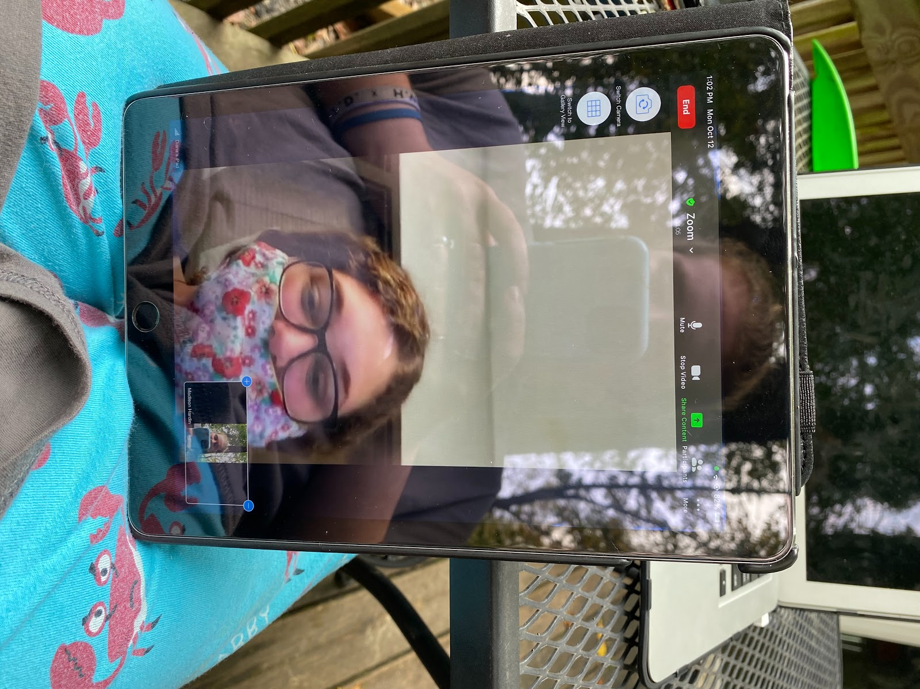

Zoom in class on October 12th. Dr. D listened to us talk to each other during class. Cason used Dr. D’s iPad and Madison used hers from home and shared her screen so both students could look at the apps together.

