Name Cassidy Brewer Snyder
Lesson Plan
Learning Segment Focus History Lesson 1 of 1

Course & topic addressed Social Studies – Contextualization Date Fall 2020 Grade 2nd

Student Outcomes
Specific learning objectives for this lesson. | Students will learn about various historical symbols and landmarks and their importance to The United States of America.
Justify how learning tasks are appropriate using examples of students’ prior academic learning. | In Kindergarten and 1st grade, my students have learned the purpose of holidays and the people associated with the holidays. This has taught them to think about certain things and why we have them/their necessity.
Justify how learning tasks are appropriate using examples of students’ personal, cultural, linguistic, or community assets. | Most 2nd graders are around 9 and 10 years old. They have been exposed to TV where they may have seen landmarks, or they may have even taken trips to certain places, or they have simply heard of things. Learning this task will serve as a foundation as they continue through school and outside the classroom as well.

State Academic Content Standards
List the state academic content standards with which this lesson is aligned. Include abbreviation, number & text of the standard(s). | H.12.2.5 – Explain historical symbols and landmarks and the people and events associated with them

Key Vocabulary
What vocabulary terms/content specific terminology must be addressed for students to master the content?

Academic Language Support
What are the Academic Language Function(s) (the content and language focus of the learning task represented by the active verbs within the learning objectives/outcomes) and explain how they are utilized in the lesson plan?  What planned Academic Language Supports will you use to assist students in their understanding of key academic language to express and develop their content learning and to provide varying supports for students at different levels of Academic Language development? How do these supports address all three Academic Language Demands (vocabulary, syntax, and discourse)? | As my students complete the activity, they will have the opportunity to discuss things with their group, as well as with the class at the end. Included in the activity is a “word hunt” where they will be on the lookout for the vocabulary words for this lesson. As an Academic Language Support, I will make sure to notice the vocabulary word present, to make sure it is accounted for. Students will also volunteer to write the word on our whiteboard. At the end of the class, we will conclude with the vocabulary words/main ideas of the lesson.

Materials
Materials needed by teacher for this lesson. (such as books, writing materials, computers, models, colored paper, etc.) | Attached graphic overview of each landmark, models to represent each landmark, whiteboard and markers, landmarks worksheet for review
Materials needed by students for this lesson. (computers, journals, textbook, etc.) | Journals and writing materials

Lesson Timeline with Instructional Strategies & Learning Tasks
Amount of Time | Teaching & Learning Activities (This should be a BULLETED LIST) | Describe what YOU (teacher) will be doing and/or what STUDENTS will be doing during this part of the lesson. (This should be VERY DETAILED)
15 minutes | Introduction:  - Go over directions for activity  - Discuss vocabulary | ME  I will begin by explaining the room setup to the students so that they have a better understanding of the activity. I will tell them my expectations for the activity, and we will discuss the vocabulary words they need to look for. I will also have an assortment of costumes/props (so that they can pretend to be tourists) for my students if they did not bring any from home. Although we will be in one group as we “road trip” the classroom, I will assign smaller groups that the students can interact with during the activity.  STUDENTS  The students will listen to the instructions for the activity. Then we will go over vocabulary as a class. They will take out their journals and writing utensils to prepare for the activity.
30 minutes | Instruction:  - Travel “The USA” and document landmarks and discuss things associated with them  - Write vocabulary on board as we come across them on our trip  - View models of landmarks around the classroom  - Fill out worksheet | ME  I will start the activity by taking the students to our first landmark, Mount Rushmore. I will give a short explanation on the importance of this landmark and the presidents involved. I will point out vocabulary to make sure they picked up on the important points. If a student volunteers, they may write the vocabulary word on the whiteboard. I will allow the students time to view the model of Mount Rushmore and fill in the graphic bubbles under the matching landmark. This will continue as we go through the remaining landmarks, their importance and those involved.  STUDENTS  The students will listen to a short explanation of the importance and the people involved in the landmarks. They will get to see/touch the models representing each landmark. If they do not catch the vocabulary words, the words will be pointed out to them. Students will have the chance to write the words on the whiteboard. We will continue this as we talk about each landmark. After we have finished our “road trip”, students will fill out their landmark worksheet.
15 minutes | Closure:  - Write in “What We Learned Journals”  - Review | BOTH  We will write what we learned from the lesson in our journals. Then we will briefly review the main ideas/vocabulary.

Accommodations/Modifications
How might I modify instruction for:  Remediation?  Intervention?  IEP/504?  LEP/ESL?  (All students who have plans mandated by federal and state law.) | .If I notice that students are struggling to pick up on the vocabulary words during our activity, I will point them out myself and after the activity, we will discuss them more in depth as a class.

Differentiation
How might you provide a variety of techniques (enhanced scaffolding, explicit instruction, contextualized materials, highlighters/color coding, etc.) to ensure all student needs are met?  (All students who are not on specific plans mandated by federal and state law.) | Students will be able to interact with the models of each landmark and move around continuously during the activity. We will also utilize writing on the board and speaking to each other.

Assessments: Formative and/or Summative
Describe the tools/procedures that will be used in this lesson to monitor students’ learning of the lesson objective(s) (include type of assessment & what is assessed). | ☐ Formative /☐ Summative | The planned activity keeps me interacting with the students so that I can easily monitor their receptiveness to the lesson.
 | ☐ Formative /☐ Summative | As students write in their journals, I will be able to see how effect the lesson was in teaching the standard.
 | ☐ Formative /☐ Summative

Research/Theory
Explain connections to theories and/or research (as well as experts in the field or national organization positions) that support the approach you chose and justify your choices using principles of the connected theories and/or research. | I believe social interaction is important for students, especially at a young age. By making a group activity, I think that students will have an easier opportunity to interact with each other. Also, my hands-on learners will be able to interact with small scale models of the landmarks mentioned. I think this will help make something, that could be abstract to their minds, real.

Lesson Reflection/Evaluation
What went well?  What changes should be made?  How will I use assessment data for next steps? | TO BE FILLED IN AFTER TEACHING

Include supporting material such as slides, pictures, copy of textbook, and handouts for any activities students will be using as part of your lesson.

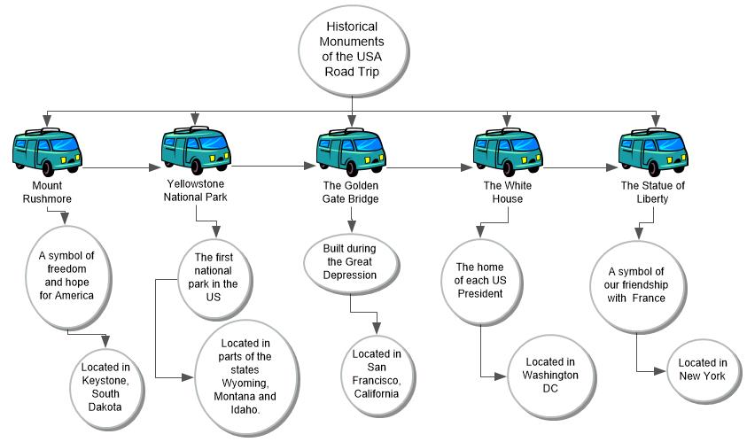
*adapted from: http://webcache.googleusercontent.com/search?q=cache:EsQcNWuG1ZoJ:web.mnstate.edu/harms/StudentTeachers/edTPA-LessonPlan.doc+&cd=2&hl=en&ct=clnk&gl=us; http://www.moreheadstate.edu/getmedia/cd3fd026-939f-4a47-a938-29c06d74ca01/Lesson-Plan-and-Reflections.aspx; http://www.mcneese.edu/f/c/9cb690d2/Lesson%20Plan%20Rubric%20Aligned%20with%20InTASC.docx;https://www.uwsp.edu/education/Documents/edTPA/Resource12.pdf; https://www.uwsp.edu/education/Documents/edTPA/Resource11.pdf; https://www.uwsp.edu/education/Documents/edTPA/Resource11a.pdf; https://www.uwsp.edu/education/Documents/edTPA/LessonPlanTemplateSOE.docx; https://www.uwsp.edu/education/Documents/edTPA/SpecEdLessonPlanGuide.docx; https://www.uwsp.edu/education/Documents/edTPA/SpecEdLessonPlanTemplate.docx

