Acceptable Use Policy
Rules at home:
1._________________________________________
2._________________________________________
3._________________________________________
4._________________________________________
5._________________________________________
Technology Rules at home:
1._________________________________________
2._________________________________________
3._________________________________________
4._________________________________________
5._________________________________________
Internet Rules at home:
1._________________________________________
2._________________________________________

3._________________________________________
4._________________________________________
5._________________________________________
Consequences:
1._________________________________________
2._________________________________________
3._________________________________________

I have read and agree to the rules and consequences of my home AUP.

___________________________________
Childs Signature

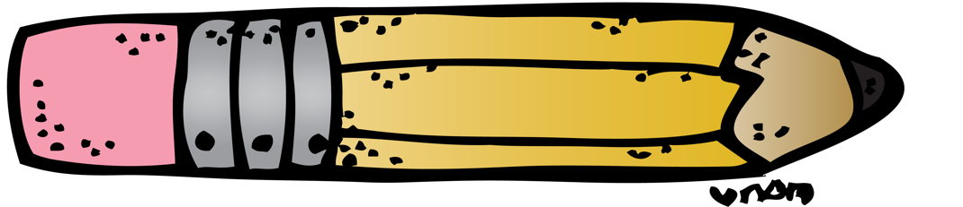
______________
Date

____________________________________
Parent Signature

______________
Date

