Online Tools:

Canva  
<https://www.canva.com/>

Canva is a great tool to use. It is very diverse and easy to use. You can create posters, informational one pagers, and almost any project. I would put this in the graphic design category.

I plan on using this frequently in my classroom. I will have projects they will have to use canva for, like our philanthropy posters.

<https://www.canva.com/design/DAEbqmoS4R0/share/preview?token=bkC19wKeL9oFA3-9RCIdWw&role=EDITOR&utm_content=DAEbqmoS4R0&utm_campaign=designshare&utm_medium=link&utm_source=sharebutton>

Mind Meister

<https://www.mindmeister.com/welcome?product=1>

This is a mind mapping tool that is really easy to use. All you have to do is start with a tile and build on from there. You can move the bubbles around how you like, and even add cool emojis.

I think that it would be a great start up tool in my class room to help categorize what we learn in the classroom such as the phases of the moon, the animal kingdom and so forth.

<https://mm.tt/1859360660?t=NW1FdWrh3l>

Kleki

<https://kleki.com/>

This is a painting tool. I think that it was super easy to navigate. There were different textures, colors, sizes and more to use. I could even blend things together which is cool.

I would only use this in the classroom when doing certain lesson plans. Like the moon phases, they could draw on here what they know about the phases of the moon.

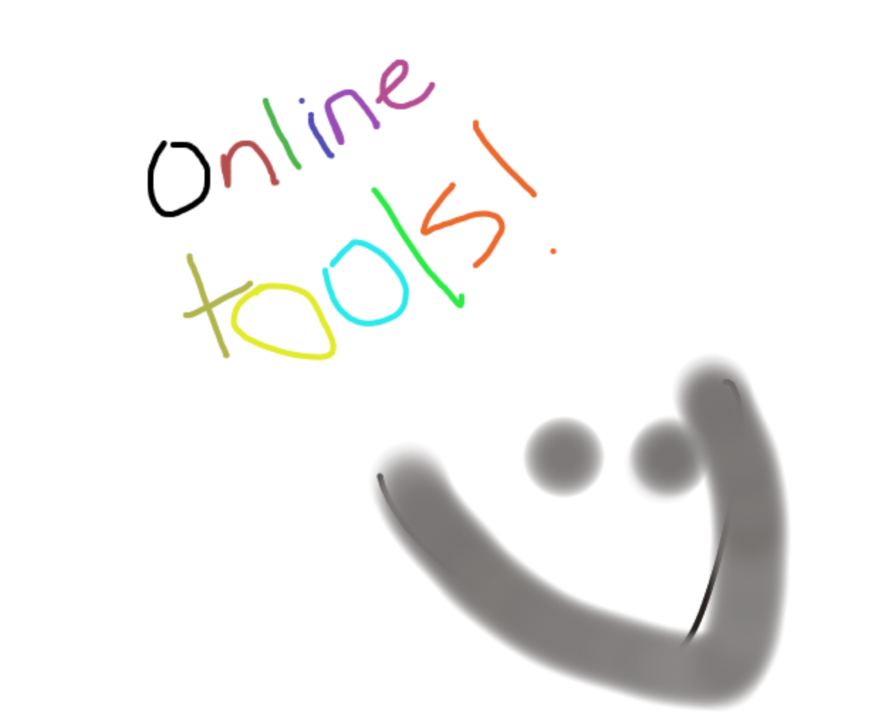

Mentimeter

<https://www.mentimeter.com/welcome/plans?steps=4&education=true>

This is a polling app. You can create different types of polls, aside of traditional boring ones, you can make super exciting ones on this site!

I would use this for assessment. I could quiz my students on materials and see where my classroom is with the information they were given. This would then give me an idea of what I need to go over more.

<https://www.menti.com/kqcvs8srdp>

Bubbl  
<https://bubbl.us>

This is another mind mapping online tool. I wanted to find a second one that was also easy to use, but different from the last one. This is just your simple mind mapping tool, but I found that this was more organized than the other one.

I would use this again during a lesson when we have to categorize things. Like animals, biomes, ect.

http://go.bubbl.us/b896fa/6b01?/Online-tools