**Spelling Bee**

**This year we will begin the**

**spelling bee at 2:00 pm in the**

**Cafeteria on November 13th!**

**The grades that will**

**participate is the 2nd through**

**the 6th grade! Feel free to come**

**join your child as they spell they’re**

**hearts out! There will be a first,**

**second, and third place prize!**

**Look Ahead November 1st**

**Set your clocks back 1 hour!**

**November 5th**

**Drop your decorated pumpkin off for judging!**

**November 9th**

**Yankee Candle sales are due!**

**November 13th**

**Spelling Bee!**

**November 17th**

**Wreath orders are Due!**

**November 23rd-27th**

**Thanksgiving Break!**

**November 30th**

**Parent Teacher Conference**

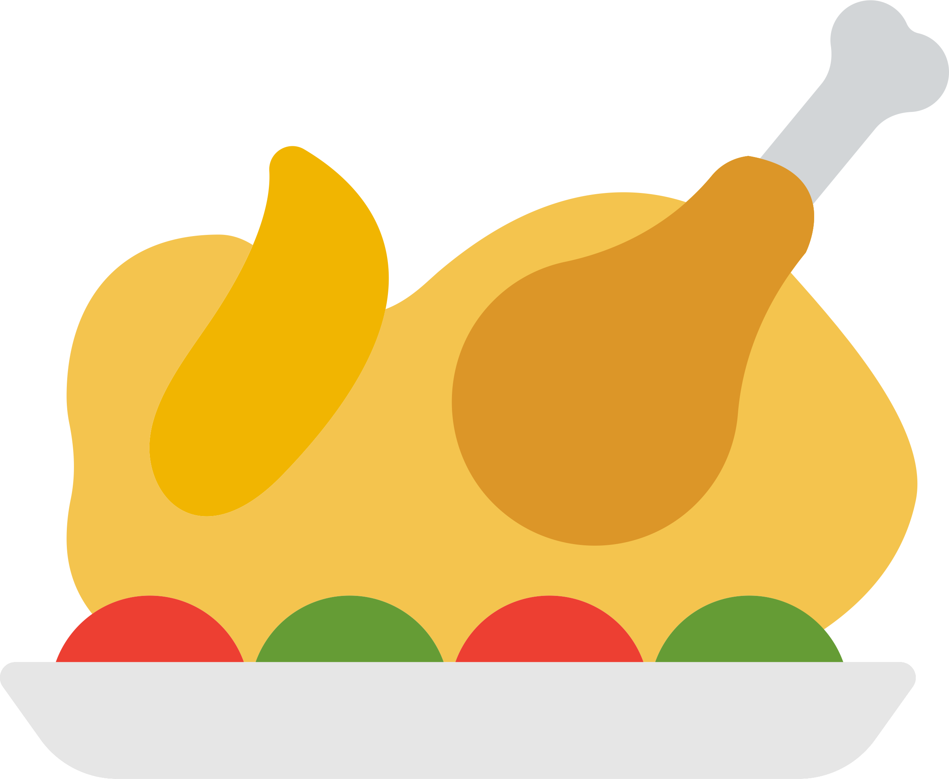**Holiday Fundraiser!!**

**We are selling chocolate candy bars for $1 each! These candy bars will help us have TV’s in each classroom so the students can watch educational videos and have brain breaks!**

Reminder!

Don’t forget that Daddy Daughter Dance is Saturday, November 15th at 6pm!

* BOOK FAIR DATES & TIMES
* November 2nd
* From 3pm-4:30pm
* November 3rd
* From 3pm-4:30pm
* November 4th
* From 2pm-4:30pm
* November 5th
* From 3pm-5pm

Caution! 

Please remember that the car rider lines should always be three lines and no one should ever park between the lines to where the lines are blocked off. Also be mindful of the students that are walking around the parking lot and to their cars, drive slow!

Alyssa Foster

MW 11am-12:15pm